

Bid Reference No. 0001/2026-27

BIDDING DOCUMENT

FOR FRAMEWORK CONTRACT

FOR THE PROCUREMENT OF

MEDICAL DEVICES / SURGICAL DISPOSABLE, SUTURE AND DRESSING ITEMS

Pak Red Crescent Medical & Dental College/
Teaching Hospital

Corresponding Address
Dina Nath, 48-KM Multan Road, Lahore Phone No. 049-4540427

FY 2026-27

TABLE OF CONTENTS

Sr No. | Heading | Page Number
 | Section-I: Invitation to Bids | 03
 | Advertisement | 04
 | Section-ii: instructions to bidders (ITB) | 04
 | Section-iii. Technical specifications | 13
 | Technical specification of surgical/ disposable items for FY-2026-27 | 13
 | Section-iv: bid data sheet | 20
 | Section-f, technical evaluation criteria | 23
 | Marking criteria-technical evaluation criteria for manufacturer/distributor | 24
 | Marking criteria-technical evaluation criteria for sole agent | 26
 | Section-V: General Conditions of Contract | 28
 | Section-vi. Schedule of requirements- ANNEX- A | 33
 | Section-vii special conditions of contract- Annex-B | 34
 | Section-viii: forms | 40
 | 8.1 Bid Form | 40
 | 8.2 Manufacturer’s Authorization Form | 42
 | 8.3 Bidder Profile Form | 43
 | 8.4 General Information Form | 44
 | 8.5 Affidavit | 45
 | 8.6 Performance Guarantee Form | 46
 | 8.7 Technical Bid Form | 47
 | 8.8 Contract Form | 49
 | Purchase order ANNEX-E | 55
 | Payment schedule ANNEX-F | 57
 | 8.9 Financial Bid Form/Price Schedule | 58
 | Section IX- Check List | 60
 | Sign & stamp of tender committee | 61

Section-I: Invitation to Bids

INVITATION TO BIDDERS
Bid Ref No. 0001/ /2026-27

FRAMEWORK CONTRACT FOR THE PROCUREMENT OF MEDICAL DEVICES/ SURGICAL DISPOSABLE, SUTURE ITEMS & DRESSINGS ETC. FOR THE FINANCIAL YEAR 2026-27)
- Bids are invited from Bidders i.e. manufactures / sole agents / sole importers of foreign principals engaged in trading, registered with relevant Registration Authorities and Tax Departments/ Authorities by Pak Red Crescent Medical & Dental College/Teaching Hospital hereinafter referred to as “Procuring agency” in this bidding document and future correspondences. The Bids shall be received as per single stage two envelop Bidding procedure.
- Bidding document are available on website i.e http://prcmdc.edu.edu.pk and can also be downloaded free of cost. The bidding documents are available immediately after the date of publication of the invitation to bid. All other details are mentioned in bidding documents.
- Bids shall be submitted on or before 21-07-2026 at 11:00AM Hours at Principal PRCTH office. The bidder shall provide 2% Bid Security in the name of Principal Pak Red Crescent Medical & Dental College/Teaching Hospital of estimated cost of quoted item(s) as mentioned in Tender Documents, in the form of Bank Draft/Bank Guarantee/Call Deposit Receipt (CDR),, Demand Draft (DD), Pay Order (PO) with Technical Proposal. The Bids submitted till stipulated date and time will be opened on the same day at 11:30AM in the presence of bidders’ representatives who may choose to be present at the address below. Interested eligible Bidders may obtain further information from Purchase Officer Pak Red Crescent Medical & Dental College/Teaching Hospital Teaching Hospital before Bid opening date within working hours. The bid security should be from company official accounts, others will not be accepted.
- Bid Validity is 180 Days from the date of opening of bids. Item(s) shall be quoted in Technical & Financial Proposal with both Brand Name(s) and Generic Name. The bidder shall enclose the Hard Copies of financial instrument (CDR), Bank draft/Pay order with technical proposal.
- The Procuring agency shall not be responsible for any cost or expense incurred by Bidders in connection with the preparation or submission of Bids. In case of official holiday on the day of opening of Bids the next day will be treated as opening date, time and venue shall remain same.
- The procuring agency may reject all bids or proposals at any time prior to the acceptance of a bid or proposal. The procuring agency shall upon request communicate to any concerned bidder, the grounds for its rejection of bids or proposals, but is not required to justify those grounds.

Sd/-
PROF. DR. KISHWAR NAHEED
PRINCIPAL
Pak Red Crescent Medical & Dental College/Teaching Hospital, Dina Nath
Ph # 049-4540286-7
Email ID: principal@prcmdc.edu.pk

ADVERTISEMENT

Section-II: Instructions to Bidders (ITB)
Note: - All the procurement procedures shall be on Single Stage Two Envelope bidding procedure.

Introduction

2.1.1  Scope of Bid | I | The Procuring Agency (PA), as indicated in the Bid Data Sheet (BDS) invites Bids for the provision of Goods as specified in the Section-IV Bid Data Sheet (BDS) and Section III - Technical Specifications & Section VII-Schedule of Requirements. The successful Bidders will be expected to deliver, The goods within the specified period and timeline(s) as stated in the BDS.
2.1.2  Source of Funds | i | The Pak Red Crescent Medical & Dental College/Teaching Hospital have sufficient budget to make eligible payments under the contract for which the Invitation to bids has been issued.
2.1.3  Eligible Bidders | I  II  III  IV  V | The Invitation to Bids is open to Original Manufacturers and Sole Agents of Foreign Principals / Sole Importer of Foreign Principals registered with relevant Registration Authorities and Tax Departments/ Authorities (Income Tax, Sales Tax & Punjab Sales Tax etc.)  Bidders should not be associated, or have been associated in the past, directly or indirectly, with a firm or any of its affiliates which have been engaged by the Procuring Agency to provide consultancy services for the preparation of the design, specifications, and other documents to be used for the procurement of the goods to be purchased under this Invitation to Bids [if applicable].  Government-owned enterprises may participate only if they are duly/legally authorized in this regard by the respective/relevant competent forum/authority.  Bidders shall not be under a declaration of blacklisting by the Procuring Agency During the Procurement Process / execution of the Contract, if the firm/ bidder is blacklisted by Procuring Agency.  The invitation for Bids is open to Original Manufacturers / Sole agents of Foreign Principals / Sole Importers of Foreign Principals subject to any provisions or licensing/regulatory requirements issued by the respective National/ Provincial Professional Statutory Body established for that particular trade or business as mentioned in bid data sheet.  A Bidder shall not have a conflict of interest. All Bidders found to have a conflict of interest shall be Non-Responsive. A Bidder may be considered to have a conflict of interest with one or more parties in this bidding process, if they:  - Are associated or have been associated for the procurement of the goods to be purchased under this Invitation for Bids, directly or indirectly with a firm or any of its affiliates which have been engaged by the Procuring Agency to provide consulting services for the preparation of the design, specifications and other documents to be used.  - Have controlling shareholders in common; or  - Receive or have received any direct or indirect subsidy from any of them; or  - Have the same legal representative for purposes of this Bid; or  - Have a relationship with each other, directly or through common third parties, that puts them in a position to have access to information about or influence on the Bid of another Bidder, or influence the decisions of the Procuring Agency regarding this Bidding process; or
 | VI  VII  VIII  IX | A Bidder may be ineligible if  - The Bidder is declared bankrupt or, in the case of company or firm, insolvent;  - Legal proceedings are established against such Bidder involving an order suspending payments and which may result, in accordance with the national laws, in a declaration of bankruptcy or in any other situation entailing the total or partial loss of the right to administer and dispose of the property;  - The Bidder is convicted, by a final judgment, of any offence involving professional conduct;  - The Bidder is debarred and blacklisted due to involvement in corrupt and fraudulent practices.  - The firm, supplier and contractor is blacklisted/ debarred by procuring agency.  Bidders shall provide to the Procuring Agency evidence of their eligibility, proof of compliance with the necessary legal requirements to carry out the contract effectively.  Bidders shall provide such evidence of their continued eligibility satisfactory to the Procuring Agency, as the Procuring Agency shall reasonably request.  Bidders shall submit proposals relating to the nature, conditions and modalities of sub-contracting wherever the sub-contracting of elements of the contract amounting to more than ten percent of the Bid price is envisaged.
Eligible Goods and Services | I  II | All goods and related services to be supplied under the Contract shall have their origin in eligible source countries, defined in the Bid Data Sheet (BDS/Technical Specification), and all expenditures made under the contract will be limited to such goods and related services.  For purposes of this clause, “origin” means the place where the goods are mined, grown, or produced, or the place from which the related services are supplied. Goods are produced when, through manufacturing, processing, or substantial and major assembly of components, a commercially-recognized product is obtained that is substantially different in basic characteristics or in purpose or utility from its components.
2.1.5  Cost of Bidding | I | The Bidder shall bear all costs associated with the preparation and submission of its Bid, and the Procuring Agency named in the Bid Data Sheet, hereinafter referred to as “the Procuring Agency,” will in no case be responsible or liable for those costs, regardless of the conduct or outcome of the Bidding process.
2.1.6  One person one bid | I  II  III | Bidder shall submit only one Bid in the same bidding process, either individually as a Bidder or as a member in a joint venture or any similar arrangement.  No Bidder can be a sub-contractor while submitting a Bid individually or as a member of a joint venture in the same Bidding process.  A Bidder, if acting in the capacity of sub-contractor in any Bid, shall not submit bid for the same.
2.2 The Bidding Documents
2.2.1  Content of Bidding Documents | I  II  III  IV | The goods required, Bidding procedures, and contract terms are prescribed in the Bidding documents. The Bidding documents, inter alia, include:  - Invitation to Bids  - Instructions to Bidders (ITB)  - Technical Specifications  - Bid Data Sheet  - General Conditions of Contract (GCC)  - Special Conditions of Contract (SCC)  - Schedule of Requirements  - Bid Form  - Manufacturer’s Authorization Form  - Bidder Profile Form  - General Information Form  - Affidavit  - Bid Security Form  - Technical Bid Form  - Contract Form  - Financial Bid Form / Price Schedule  - Performance Guarantee Form  - Check List  The Bidder is required to examine all instructions, forms, terms, and specifications in the Bidding documents. Failure to furnish all information as required by the Bidding documents or to submit a Bid not responsive to the Bidding documents in every respect will be at the Bidder’s risk and may result in the rejection of its Bid.  In case of discrepancies between the Invitation to Bid and the Bidding Documents listed in ITB (i) above, the said Bidding Documents, not in conflict with any provision, will take precedence.  The Procuring Agency is not responsible for the completeness of the Bidding Documents and their addenda, if they were not obtained directly from the Procuring Agency or from its website. Re-confirming from the Procuring Agency that all pages/ contents have been properly and clearly received is the prime responsibility of the Bidder.
2.2.2  Clarification of Bidding Documents | I  II  III  IV  V  VI  VII | A prospective Bidder requiring any clarification of the Bidding documents may notify the Procuring Agency in writing or by email at the Procuring Agency’s address indicated in Invitation to Bid/ Tender Notice/ Advertisement. The Procuring Agency will respond in writing to any request for clarification of the Bidding documents which it receives no later than seven (7) days prior to the deadline for the submission of Bids prescribed in the Bid Data Sheet.  A prospective Bidder requiring any clarification of the Bidding Documents may notify the Procuring Agency in writing or in electronic form that provides record of the content of communication at the Procuring Agency's address indicated in the BDS.  The Procuring Agency will within three (3) working days after receiving the request for clarification, respond in writing or in electronic form to any request for clarification provided that such request is received not later than seven (7) days prior to the deadline for the submission of Bids. As prescribed in, above. However, this clause shall not apply in case of alternate methods of Procurement.  Copies of the Procuring Agency's response as prescribed in clause ITB, above will be uploaded on the website of procuring agency. The prospective bidders are advised to visit the website of procuring agency regularly for any clarification issued by the procuring agency, above should the Procuring Agency deem it necessary to amend the Bidding Documents as a result of a clarification, it shall do so following the procedure  If indicated in the BDS, the Bidder’s designated representative is invited at the Bidder’s cost to attend a pre Bid meeting at the place, date and time mentioned in the BDS. During this pre Bid meeting, prospective Bidders may request clarification of the schedule of requirement, the Evaluation Criteria or any other aspects of the Bidding Documents.  At any time prior to the deadline for submission of Bids, but not later than three (3) days before the closing date of the submission of Bid, the Procuring Agency, for any reason, whether at its own initiative or in response to a clarification requested by a prospective Bidder, may modify the Bidding documents by amendment. Any such change/amendment in the Bidding documents shall be provided in a timely manner, preferably through electronic means also, not later than three (3) days, and on equal opportunity basis.  In order to allow prospective Bidders reasonable time in which to take an addendum into account in preparing their Bids, the Procuring Agency, at its discretion, may extend the deadline for the submission of Bids, in the manner similar to the original advertisements, so as to avoid any inconvenience and to doubly ensure level playing field for all prospective bidders.

2.3

Amendment of Bidding Documents
2.3.1  Pre Preparation of Bids | I | The Bid prepared by the Bidder, as well as all correspondence and documents relating to the Bid exchanged by the Bidder and the Procuring Agency shall be written in the language specified in the Bid
2.3.2  Language of Bid | I | Data Sheet. Supporting documents and printed literature furnished by the Bidder may be in same language.
2.3.3  Bid Form | I | The Bidder shall complete the Bid Form and the appropriate Price  Schedule (Financial Bid) furnished in the Bidding documents, indicating the goods to be supplied, a brief description of the goods, their country of origin, quantity, and prices.
2.3.4  Bid Prices | I  II  III  IV | The Bidder shall indicate on form 8.10 the unit prices (where applicable) and total Bid price of the goods it proposes to supply under the contract.  Prices indicated on the Price Schedule shall be as per prescribed format given in financial bid form / Price schedule (form 8.10).  The Bidder’s separation of price components in accordance with ITB Clause above will be solely for the purpose of facilitating the comparison of Bids by the Procuring Agency and will not in any way limit the Procuring Agency’s right to contract on any of the terms offered.  Prices quoted by the Bidder shall be fixed during the Bidder’s performance of the contract and not subject to variation on any account A Bid submitted with an adjustable price quotation will be treated as non-responsive and may be rejected.
2.3.5  Bid Currencies | I | Prices shall be quoted in Pak Rupees unless otherwise specified in the Bid Data Sheet.
2.3.6  Documents Establishing Bidder’s Eligibility and Qualification | I  II  III | Pursuant to ITB Clause, the Bidder shall furnish, as part of its Bid, documents establishing the Bidder’s eligibility to Bid and its qualifications to perform the contract if its Bid is accepted.  The documentary evidence of the Bidder’s eligibility to Bid shall establish to the Procuring Agency’s satisfaction that the Bidder, at the time of submission of its Bid, is eligible as defined under ITB Clause  The documentary evidence, of the Bidder’s qualifications to perform the contract if its Bid is accepted, shall establish to the Procuring Agency’s satisfaction:  - That, in the case of a Bidder offering to supply goods under the contract which the Bidder did not manufacture or otherwise produce, the Bidder has been duly authorized by the goods’ Manufacturer [Manufacturer’s Authorization form No. 8.3] or producer to supply the same in Pakistan;  - That the Bidder has the financial, technical, and production capability necessary to perform the contract;  - That the Bidder meets the qualification criteria listed in the Bid Data Sheet.
2.3.7  Documents Establishing Goods’ Eligibility and Conformity to Bidding Documents | I  II  III  IV  V  VI  VII  VIII  IX | Pursuant to ITB Clause, the Bidder shall furnish, as part of its Bid, documents establishing the eligibility and conformity to the Bidding documents of all goods and related services which the Bidder proposes to supply under the contract.  The documentary evidence of the eligibility of the goods and services shall consist of a statement in the Price Schedule/Financial Bid Form of the country of origin of the goods and services offered which shall be confirmed by a Certificate of Origin issued at the time of shipment.  The documentary evidence of conformity of the goods and services to the Bidding documents (if required) may be in the form of literature, drawings, data and shall consist of:  - a detailed description of the essential technical and performance characteristics of the goods;  - An item-by-item commentary on the Procuring Agency’s Technical Specifications demonstrating responsiveness of the goods and services to those specifications, or a statement of deviations and exceptions to the provisions of the Technical Specifications.  Where a sample(s) is required by a procuring agency, the sample shall be:  - submitted as prescribed in the BDS;  - carriage paid;  - received on, or before, the closing time and date for the submission of bids; and  - Evaluated to determine compliance with all characteristics listed in the BDS.  {However, the procuring agency may also opt to ask for samples after submission of technical bids (where require)}  The Procuring Agency may retain the sample(s) of the successful Bidder till the successful delivery of the goods. A Procuring Agency may reject the Bid if the sample(s)-  - Do(es) not conform to all characteristics  - prescribed in the bidding documents; and  - Is/are not submitted within the specified time  - Clearly mentioned in the Bid Data Sheet.  Samples made up from materials supplied by a Procuring Agency shall not be returned to a Bidder nor shall a Procuring Agency be liable for the cost of making them.  All samples produced from materials belonging to an unsuccessful Bidder may be kept by the Procuring Agency till thirty (30) days from the date of award of contract or exhaust of all the grievance forums (including those pending at Authority’s Level or in some Court of Law).  Pursuant to the requirements as indicated in ITB, the Bidder shall furnish, as part of its Bid, all those documents establishing the eligibility in conformity to the terms and conditions specified in the Bidding Documents for all goods and related services which the Bidder proposes to deliver.  The required documents and other accompanying documents must be in English. In case any other language than English is used the pertinent translation attested by the embassy in country of manufacturer into English shall be attached to the original version.
2.3.8  Bid Security | I  II  III  IV  V  VI  VII | The Bidder shall furnish, as part of its Bid, a Bid security in the amount specified in the Bid Data Sheet.  The Bid security is required to protect the Procuring Agency against the risk of Bidder’s conduct which would warrant the security’s forfeiture Pursuant to ITB Clause  The Bid security shall be in Pakistan Rupees and shall be in one of the following forms:  - Bank Guarantee, Bank call-deposit (CDR), Demand Draft (DD), Pay Order (PO) or valid for thirty (30) Days, beyond the prescribed Bid validity period in BDS.  - Any Bid not secured in accordance with ITB Clauses (i) and (ii) may be rejected by the Procuring Agency as non-responsive.  - Unsuccessful Bidders’ Bid security will be discharged or returned as promptly as possible, upon written request, after the expiration of the period of Bid validity prescribed by the Procuring Agency pursuant to ITB Clause or along with unopened financial proposal.  The financial proposal of the Bids found technically non-responsive shall be retained unopened and shall be returned on the expiry of the grievance period or the decision of the complaint, if any, filed by the non-responsive Bidder, whichever is later:  Provided that the Procuring Agency may return the sealed financial proposal earlier if the disqualified or non-responsive Bidder.  The successful Bidder’s Bid security will be discharged upon the Bidder signing the contract, pursuant to ITB Clause, and furnishing the Performance Guarantee, pursuant to ITB Clause.  The Bid security may be forfeited:  - If a Bidder withdraws its Bid during the period of Bid validity specified by the Bidder on the Bid Form; or  - In the case of a successful Bidder, if the Bidder:  - Fails to sign the contract in accordance with ITB Clause; or  - Fails to furnish Performance Guarantee in accordance with ITB Clause; or  - If the blacklisting proceedings are initiated and the bidder is declared blacklisted after due process of law.
2.3.9  Pe Period of Validity of Bids  - iod of Validy | I  II  III | Bids shall remain valid for the period specified in the Bid Data Sheet after the date of Bid opening prescribed by the Procuring Agency. A Bid valid for a shorter period may be rejected by the Procuring Agency as non-responsive.  In exceptional circumstances, the Procuring Agency may solicit the Bidder’s consent to an extension of the period of validity. The request and the responses thereto shall be made in writing. The Bid security provided under ITB  Clause shall also be suitably extended. A Bidder may refuse the request without forfeiting its Bid security. A Bidder accepting the request will not be required nor permitted to modify its Bid.
2.3.10  Format and Signing of Bid | I  II  III  IV  V  VI | The Bidder shall prepare Bid indicated in the Bid Data Sheet.  The Bidder shall authorize a person/ persons for signing, submission and further correspondence with Procuring Agency on behalf of bidder. Authority letter must be part of Bid. However, in case of any issue bidder shall be responsible for all consequences.  The Bid shall be typed or written in indelible ink and shall be signed by the Bidder or a person duly authorized to bind the Bidder to the contract. All pages of the Bid, shall be signed and stamped by the authorized person.  Any interlineation, erasures, or overwriting shall not be accepted and such bid shall be rejected.  The Bid shall be typed or written in indelible ink and shall be signed by the Bidder or a person duly authorized to sign on behalf of the Bidder.  This authorization shall consist of a written confirmation as specified in the BDS and shall be attached to the Bid. The name and position held by each person signing the authorization must be typed or printed below the signature. All pages of the Bid, shall be signed and stamped by the authorized person.
2.3.11  Submission of Bids | I  II  III | Sealing and Marking of Bids the submission of file by the bidders shall be deemed submission in “envelope” or “package” as mentioned in the rules.  The bidder shall submit hard copy of Financial Instrument with technical proposal.  Any envelope or parcel containing the Bid Security / samples / catalogues/documents, where applicable, shall:  - bear the name and address of the Bidder;  - be addressed to the Procuring Agency in accordance with ITB Sub-Clause;  - bear the specific identification of this bidding process indicated in ITB and any additional identification marks as specified in the BDS, and

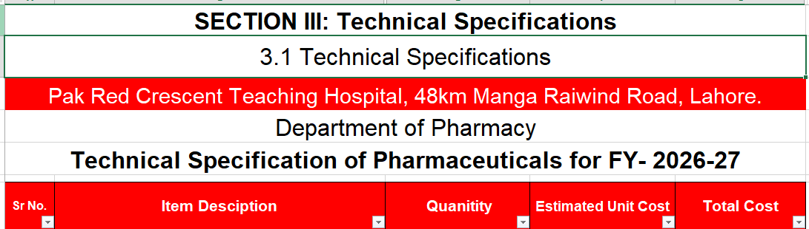
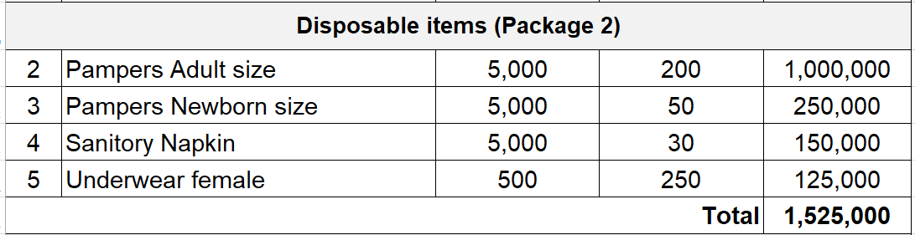
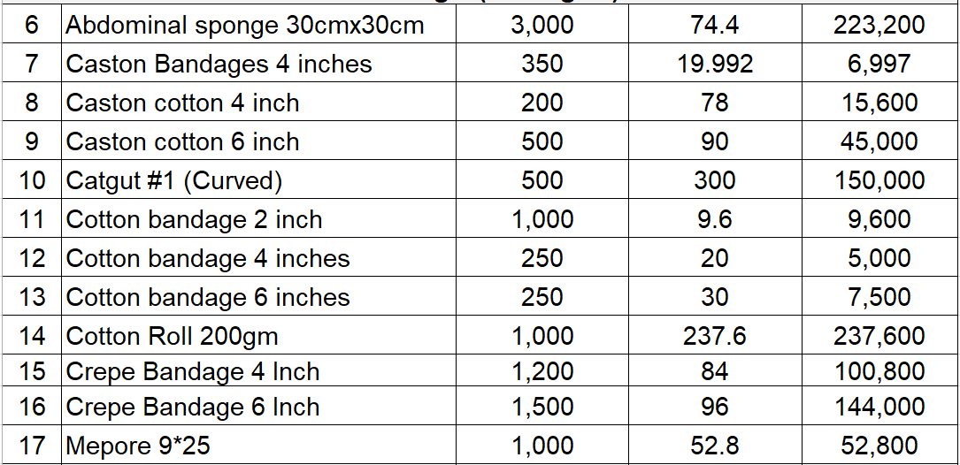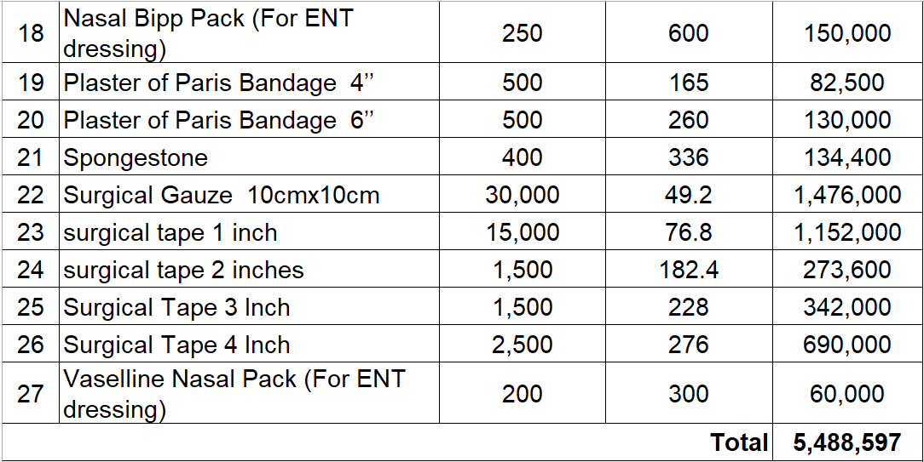

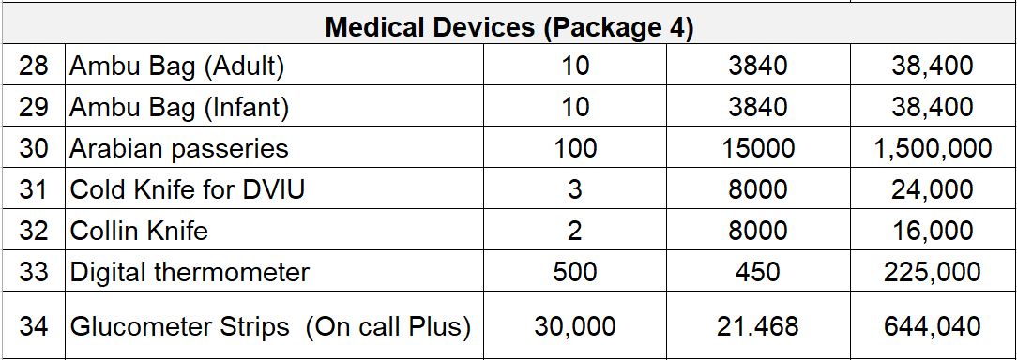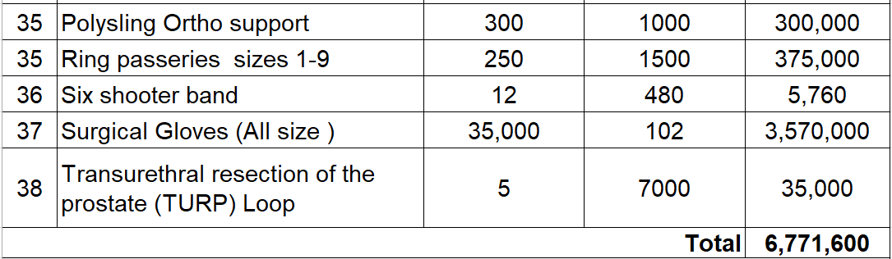

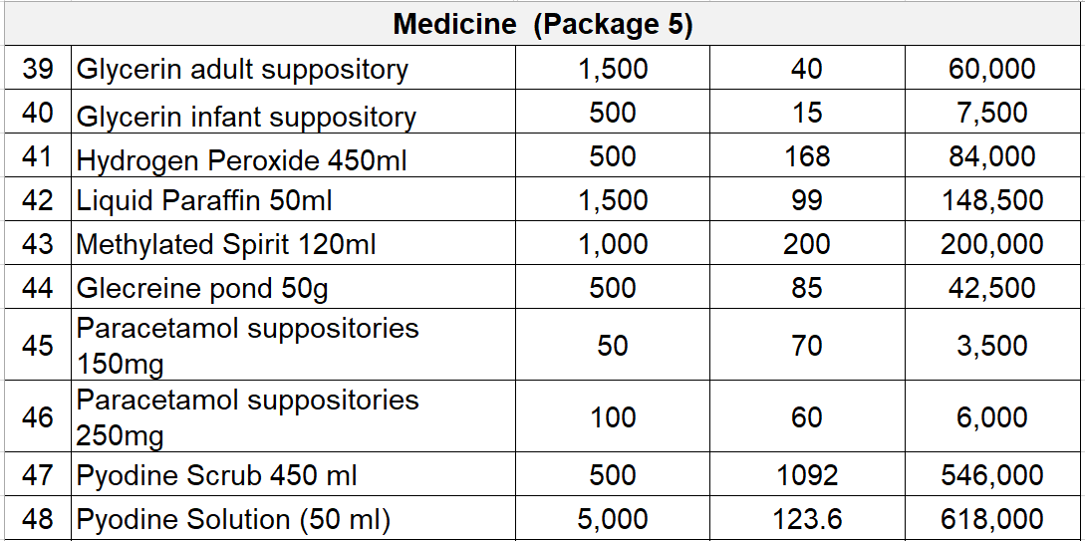

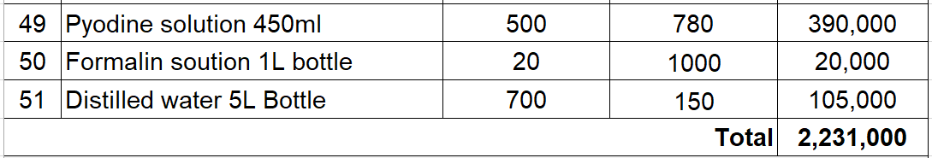

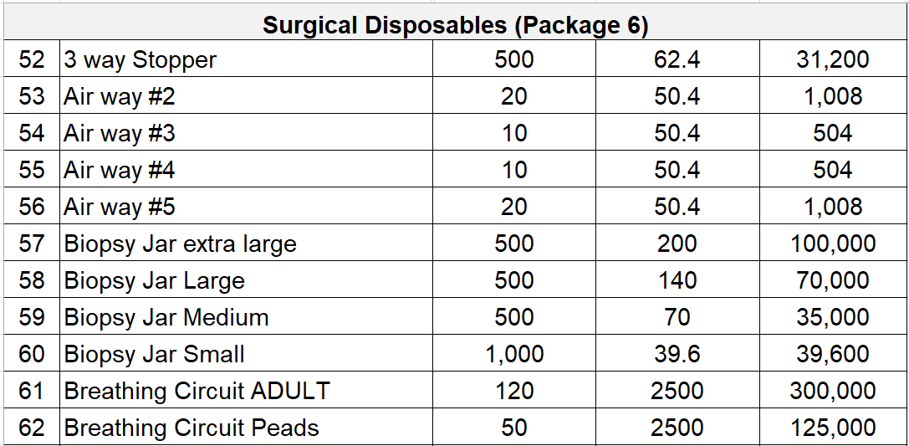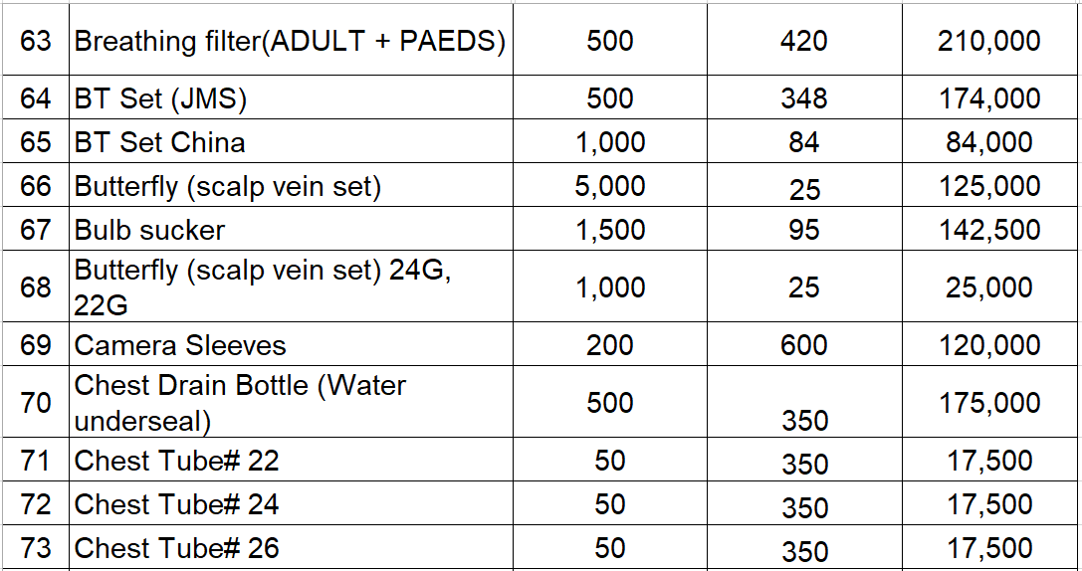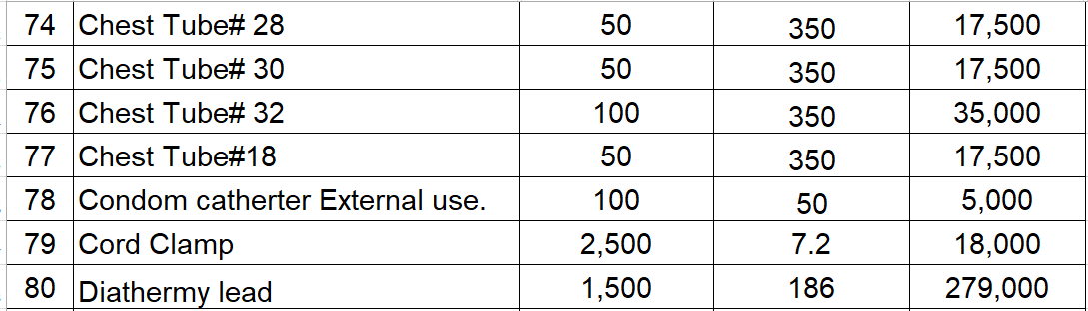

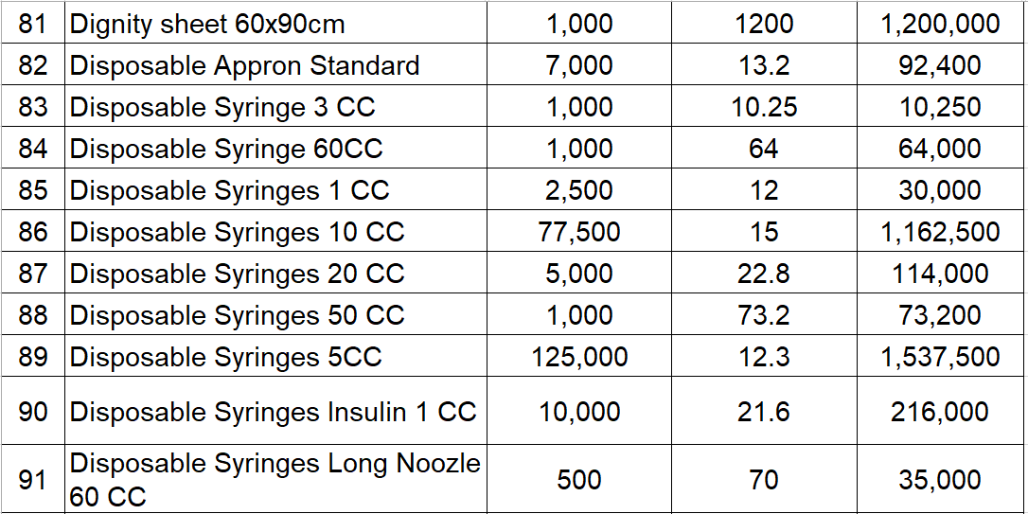

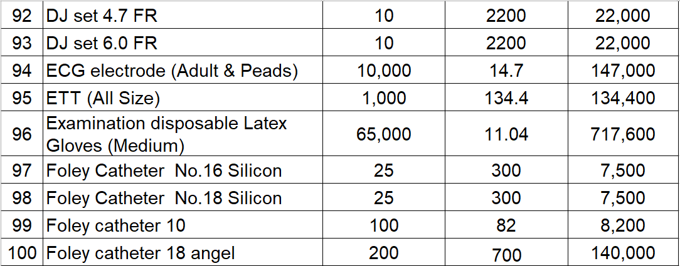

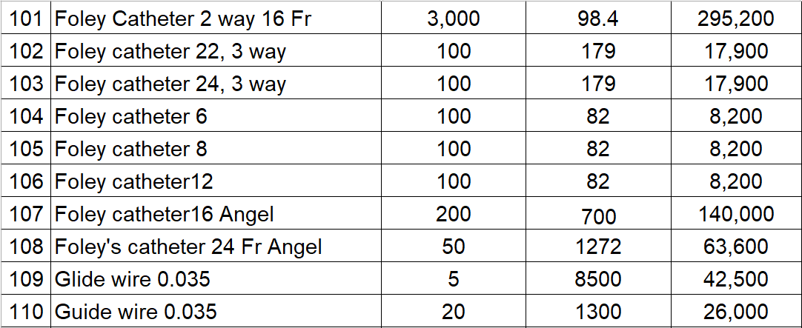

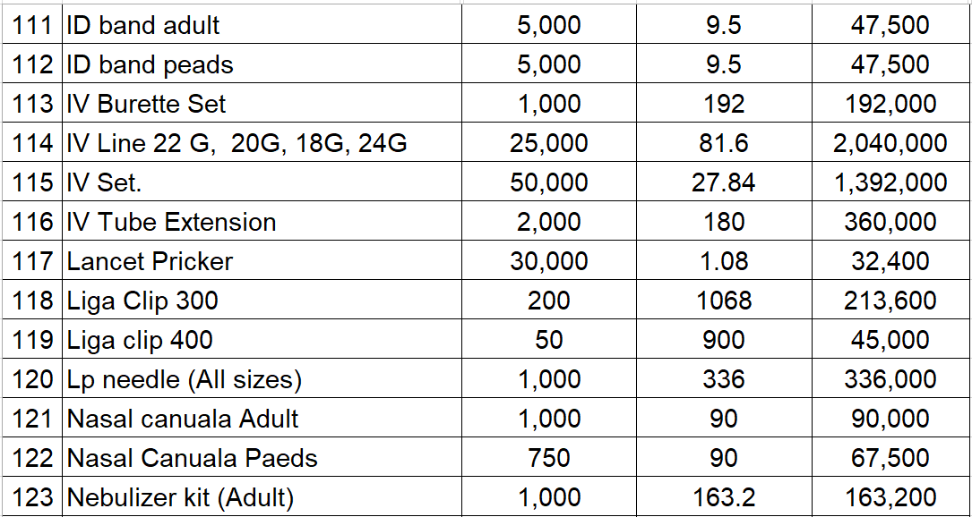

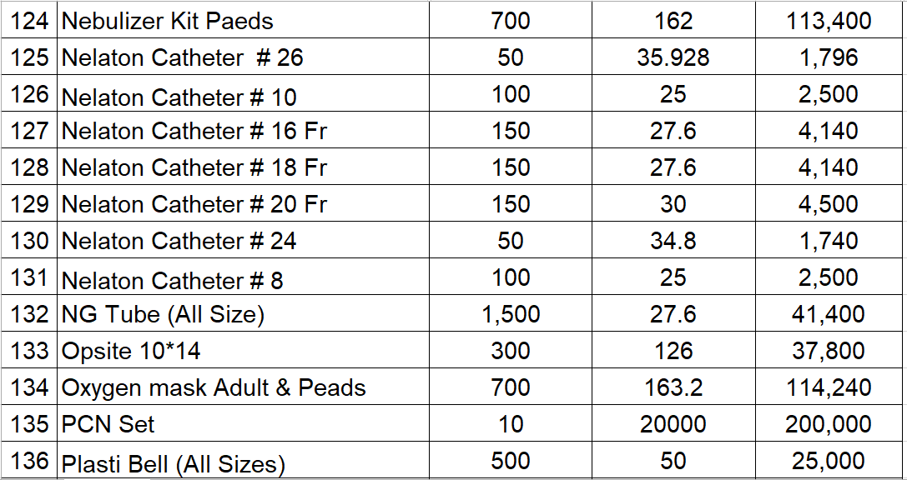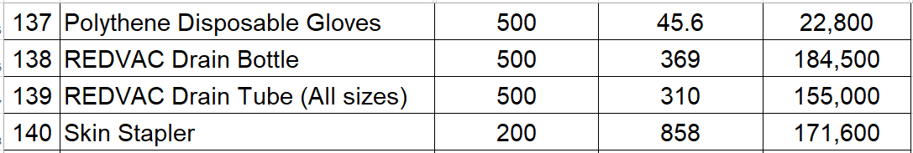

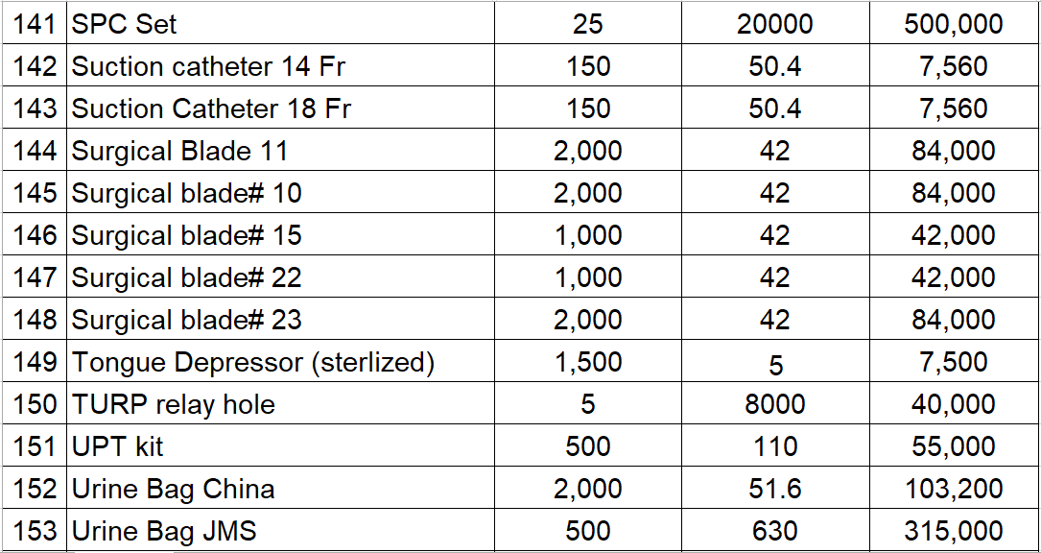

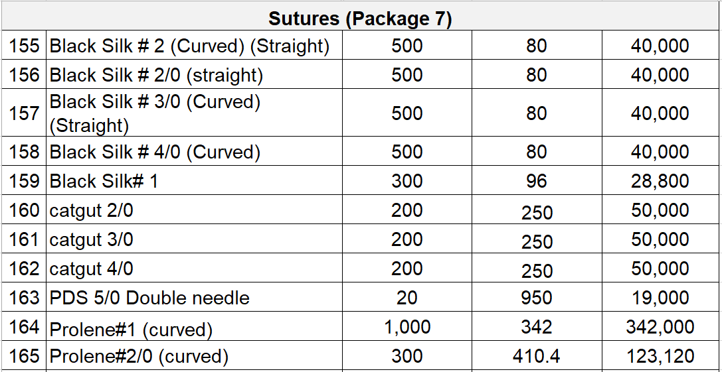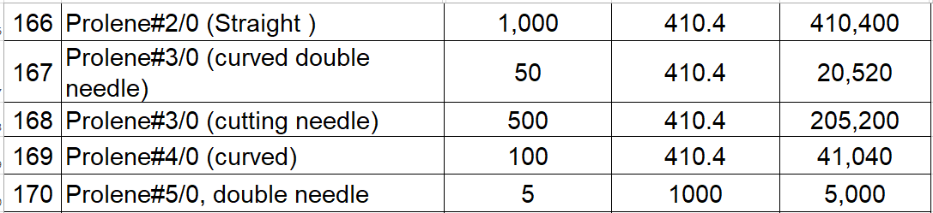

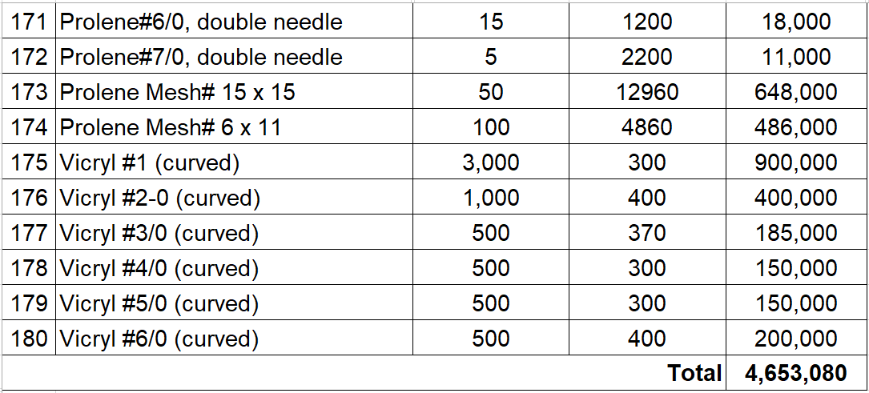
Note:
      - The estimated cost is for calculation of bid security only. Moreover, in case of variation in pack size of dosage form (liquid) rates will be calculated on per ml basis.
      - The Bidder shall provide sample(s) {number & requirement to be decided by the procuring agency} in commercial packs of the quoted brand of each quoted item for Medical Devices/ surgical, disposable, suture and dressing items / drugs and sample(s) / brochure (s) {number & requirement to be decided by the procuring agency} in commercial packs of medical devices along with its bid or as required by the Technical Bid Evaluation Committee. Packaging/packing material of the Medical Devices shall be of same quality/strength/gauge/grammage as supplied in local market.
      - The packaging of sample glass bottle (oral/injectable) and plastic bottle/HDPE/PVDC material shall be as per commercially available pharmaceutical finished product packaging.
      - Certificate regarding fulfillments of requirements under Bio Safety Act 2005 and the rules framed there under must be attached for Vaccines/Sera, Biotechnical products etc.
      - For thermo labile drugs for which storage temperature is 2-8 degree centigrade. The firm shall be bound to produce batch wise cold chain data from the source of origin & theology data from factory to Consignee’s end.
      - Diluents / solvents shall have expiry date equal to more than primary product
Any further information can be obtained from the office of Purchase Section of the Procuring Agency Pak Red Crescent Medical & Dental College/Teaching Hospital.

Section-IV: Bid Data Sheet
The following specific data for the goods to be procured shall complement, supplement, or amend the provisions in the Instructions to Bidders (ITB) Section II. Whenever there is a conflict, the provisions herein shall prevail over those in ITB.

A. Introduction
BDS  Clause # | ITB # | Amendments of, and Supplements to, Clauses in the Instruction to Bidders
1. | 2.1.1 | Name of Procuring Agency:  (Pak Red Crescent Medical & Dental College / Teaching Hospital) The subject of procurement :  Framework Contract for the Procurement of Medical Devices/ surgical, disposable, suture and dressing items, Medical Devices & Surgical Dressings etc.  Place of Delivery of goods: The goods will be delivered at Consignee’s End (Procuring Agency/its designated place).  Commencement date for delivery of Goods: Date of Signing of Contract / Purchase Order Issuance date as the case may be
2. | 2.1.2 | Financial year for the operations of the Procuring Agency:  Financial Year 2026-27  Name of financing institution: Pak Red Crescent Society Punjab  Name and identification number of the Contract:  Framework Contract for the Procurement of Medical Devices/ surgical, disposable, suture and dressing items.  Bid Reference No. 0001/2026-27
3. | 2.1.3 (iv) | Joint venture is not allowed.
4. |  | Ineligible country(s): All goods and related services to be supplied under the contract that are required to be imported in Pakistan shall have their origin in eligible source countries as prescribed by the commercial policies of Government of Pakistan and all expenditures made under the contract shall be limited to such goods and services.\
5. | 2.3.6(iii) | Demonstration of authorization by manufacturer:  The bidder shall submit the authorization by manufacturer as per Form 8.3.
6. | 2.2.2 | The address for clarification of Bidding Documents is (Pak Red Crescent Medical & Dental College / Teaching Hospital)
7. | 2.2.2 | PRE Bid meeting has been scheduled For  Day Wednesday  Date : 15--07-2026  Time : 11:00 AM hours  Venue: (Committee Room Pak Red Crescent Medial & Teaching Hospital, Dina Nath, 48km Multan Road Lahore)
8 | 2.3.9 | One (01) complete bid (including separate Technical Bid & Financial Bid) is required to be submitted in original.
C. Bid Price, Currency, Language and Country of Origin
9 | 2.3.1 | Language of the bid will be English.  The required documents and other accompanying documents must be in English.
10 | 2.3.4 | The price quoted shall be in Pak Rupee (PKR) inclusive applicable taxes.
11. | 2.3.4 | The quoted price of the item shall not be higher than the Trade Price as per MRP fixed by DRAP / benchmark prices notified by the DRAP.
12. | 2.1.4 (ii) | Country of origin: All goods and related services to be supplied under the contract that are required to be imported in Pakistan shall have their origin in eligible source countries as prescribed by the commercial policies of Government of Pakistan.
D. Preparation and Submission of Bids
13. | 2.1.3 | Evaluation criteria is described in sub-section “Bid Evaluation Criteria” of the Bid Data Sheet.
14. | 2.2.2 | Bid shall be submitted to:  Principal Pak Red Crescent Medial & Teaching Hospital, Dina Nath, 48km Multan Road Lahore
15. | 2.2.3 | Pre Bid Meeting  Day Wednesday  Date : 15--07-2026  Time : 11:00 AM hours  Venue: (Committee Room Pak Red Crescent Medial & Teaching Hospital,  Dina Nath, 48km Multan Road Lahore)
16. | 2.4.2 | The deadline for Bid submission is  Day Wednesday  Date : 21-07-2026  Time : 11:00 AM hours
17. | 2.5.1 | Bid opening.  Day : Tuesday  Date : 21-07-2026  Time : 11:30 AM hours  Venue : (Committee Room Pak Red Crescent Medial & Teaching Hospital,  Dina Nath, 48km Multan Road Lahore)
18. | 2.6.2 | Amount of Performance Guarantee is 5% (to be decided by the Procuring Agency) of the value of contract / purchase order. Performance Guarantee will be in PKR.
19. | 2.3.7 | Amount of Bid Security is 2% (to be decided by the Procuring Agency) of Estimated Cost of the quoted Item (s) as given in Bidding Document against each package.
20. | 2.3.9 | Bid validity period after opening of the Bid is 180 days (to be decided by the procuring agency).
21 | 2.3.9 | Number of copies of the Bid to be provided is Not required.
E. Opening and Evaluation of Bids
22. | 2.5.1 | The Bid opening shall take place at:  Day : Tuesday  Date : 21-07-2026  Time : 11:30 AM hours  Venue : (Committee Room Pak Red Crescent Medial & Teaching Hospital,  Dina Nath, 48km Multan Road Lahore)

SECTION - F

Technical Evolution Criteria

BIDS EVALUATION CRITERIA FOR DRUGS / MEDICAL DEVICES/ SURGICAL, DISPOSABLE, SUTURE AND DRESSING ITEMS FOR MANUFACTURER/DISTRIBUTORS

Failure to comply with any compulsory parameter / knockout clauses will result in "non-responsiveness of the bidder for quoted item". Bidders complying with Compulsory Parameters/knockout clauses will be evaluated further for Marking Criteria.

COMPULSORY PARAMETERS / KNOCKOUT CRITERIA

- Original slip regarding payment of tender fees
- The bidder must possess a valid Drug Manufacturing License issued by DRAP (Manufacturers) / Drug Sales License (Distributor).
- The bidder will provide a valid Drug Registration Certificate of the quoted product
- The product having a minimum of One year's experience will be eligible
- Valid GMP Certificate issued by the DRAP for the manufacturer
- Specifications of Medical Devices/ surgical, disposable, suture and dressing items quoted in the technical offer will be verified from samples provided with the bid
- Products that comply with the advertised specifications of Medical Devices/ surgical, disposable, suture and dressing items and fulfill the requirements as per rules shall be considered irrespective of pack size, which would be acceptable according to the pack size of respective qualified firms
- Undertaking on valid E-stamp paper worth Rs.100/- regarding "Non-Declaration of Sub Standard / Spurious / Adulterated Batch" by any notified Drug Testing Laboratory / NIH Islamabad of quoted item within the last one year
- Undertaking on Valid E-Stamp Paper worth Rs.100/- to the effect of Non-cancellation / suspension of drug registration of the quoted product of the bidder / manufacturer by DRAP and Non-conviction from any court of law and blacklisting
- Two commercial packs as samples of quoted Medical Devices/ surgical, disposable, suture and dressing items for evaluation by the technical committee.

MARKING CRITERIA
Technical Evaluation Criteria for Manufacturers / Distributor
Sr# | Description | Category Points
1 | Source of API of Quoted Item | 10
i) | Original Source / Research Molecule (Affidavit on firm's letterhead) | 10
ii) | Source Licensed by Original or accredited by FDA/WHO/EMA (Certificate) (The bidder must provide import record of one year from June 2025 to till now i.e. copy of GD/LC of quoted raw material source) | 08
iii) | Other Source of Raw Material with Certificate of Analysis (June 2023 to onwards) | 05
2 | Bio-Equivalence / Bio-similarity Study (if applicable) of Quoted Product in finished form (affidavit on Rs:100 stamp paper in case of research molecule) | 05
i) | Innovator / Original Manufacturer will be awarded full marks | 05
ii) | Bio-equivalence / Bio-similarity Study from WHO prequalified Laboratories OR Lab certified / Audited by SRAs of ICH Member Countries (The firm will attach Bio-equivalence/ Bio-Similarity certificate of the finished product) | 03
3 | EXPERIENCE OF THE QUOTED PRODUCT FOR ANY ONE YEAR from 2024 till 2026 | 20  .
 | Past performance of quoted product with major Government Sector / Semi-Govt / Private Sector / autonomous body during any one year 2024-2025 / 2025-2026 (The bidder shall provide verifiable documentary evidences like commercial sales summary / supply order of the quoted product)
i) | Supply of the quoted product Higher than the advertised quantity | 20.
ii) | Supply of the quoted product Equivalent to the advertised quantity. | 15.
iii) | Supply of the quoted product at least 60% of advertised quantity. | 10.
4 | Availability of product at major chain pharmacies. | 20.
 | (The bidder shall provide verifiable documentary evidence (invoices) regarding availability of quoted items. Pharmacy chain will be any company operating upto 3 pharmacies in any one major city of Punjab. Hospital Items / Specialized Hospital Items and Anti-Cancer Items may be exempted from said requirement. In such cases, Hospitals P.O/Prescriptions or Invoice will be considered maximum up to 20 Marks. Summary of Invoices shall be provided which could be verified. Any false claim/concealment shall be considered as fraudulent practice)
i) | Supply of quoted product at 3 chain pharmacies. | 20.
ii) | Supply of quoted product at 2 chain pharmacies. | 15.
iii) | Supply of quoted product at 1 chain pharmacy. | 08.
5 | FINANCIAL CAPACITY OF THE BIDDER AND MANUFACTURER. | 20
 | Annual Turnover (total net sales) of Bidder for last year 2024-2025 The financial worth of holding company will be considered for subsidiary, subject to provision of verifiable proof... (The bidder shall provide complete Income Tax Returns issued by FBR & Audited Financial Statements)
i) | 100 Million Or above. | 20.
ii) | Between 50 to 99 Million. | 15.
iii) | Less than 50 Million. | 10.
6 | Valid ISO Certifications (ISO certificate issuing organization / authority must be approved from PNAC / UKAS / IAF / IAS). | 10  .
7 | Technical staff of manufacturer. | 5
i) | Plant manager | 2.
ii) | Production pharmacist. | 1.
iii) | QC manager / QC analyst. | 1.
iv) | QA manager / QA inspector. | 1.
08 | PREQUALIFICATION OF THE BIDDER / MANUFACTURER WITH Government /Semi Government/ Autonomous body/ Private Organization | 10
I. | Prequalification with Govt. organization | 5
II. | Prequalification with Semi Govt/ Autonomous/ Private organization | 5
 | Total | 100
Note: For product where the criteria of Bio-Equivalence Bio/similarity and API Source is not applicable, the bidder will be evaluated on rest of parameter and qualifying marks will be 60%

Qualifying Marks 60 out of 100 (60%)
Financial bid of only "technically qualifying bidders" will be opened.

BIDS EVALUATION CRITERIA FOR SOLE AGENTS (DRUG / MEDICAL DEVICES/ SURGICAL, DISPOSABLE, SUTURE AND DRESSING ITEMS)
Failure to comply with any compulsory parameter / knockout clauses will result in "non-responsiveness of the bidder for quoted item". Bidders comply with Compulsory Parameters / knockout clauses will be evaluated further for Marking Criteria.

COMPULSORY PARAMETERS / KNOCKOUT CRITERIA
- Original receipt regarding payment of tender fees.
- The bidder must possess valid Drug Sale License (in case of importers).
- The bidder will provide valid Drug Registration Certificate of the quoted product. The product having minimum One-year experience will be eligible.
- Valid GMP Certificate from manufacturer.
- Specifications of Medical Devices/ surgical, disposable, suture and dressing items quoted in the technical offer will be verified from samples provided with the bid. Product that comply with the advertised specifications of Medical Devices/ surgical, disposable, suture and dressing items and fulfil the requirements as per rules shall be considered irrespective of pack size which would be acceptable according to pack size of respective qualified firms.
- Undertaking on Valid E-stamp paper worth Rs. 100/- regarding "Non Declaration of Sub Standard / Spurious / Adulterated Batch" by any notified Drug Testing Laboratory of quoted item within last one year.
- Undertaking on Valid E-Stamp Paper worth Rs. 100/- to the effect that Non-cancellation / suspension of drug registration of quoted product of the bidder by DRAP and Non-conviction from any court of law and black listing.
- Two commercial packs as samples of quoted Medical Devices/ surgical, disposable, suture and dressing items for evaluation by the technical committee.

MARKING CRITERIA
TECHNICAL EVALUATION CRITERIA FOR SOLE AGENT
Sr # | Description | Category Points
1 | Source of API of Quoted Item | 10
i) | Original Source / Research Molecule (Affidavit on firm's letter head) | 10
ii) | Source Licensed by Original or accredited by FDA/WHO/EMA (Certificate)  (The bidder must provide Import record of one year (from June 2024 to onwards) i.e. copy of GD/LC of quoted raw material source) | 08
iii) | Others Source of Raw Material with Certificate of Analysis (June 2024 to onwards) | 05
2 | Bio Equivalence / Bio-similarity Study (if applicable) of Quoted Product (affidavit on Rs:100 stamp paper in case of research molecule)* | 05
i) | Original Manufacturer will be awarded full marks. | 05
ii) | Bio equivalence/Bio-similarity Study from any of the below mentioned labs:  • WHO prequalified Laboratories  • Lab certified / Audited by SRAs of ICH (International Conference on | 03
Sr. # | Description | Category Points
Harmonization) Member Countries.
(The firm will attach Bio-equivalence/ Bio-Similarity certificate of the finished product).
3 | EXPERIENCE OF THE QUOTED PRODUCT FOR ANY ONE YEAR 2024-2025 / 2025-2026.  Past performance of quoted product with major Government Sector/ Private Sector/during any one year 2024-2025 / 2025-2026. | 15
i) | Supply of the quoted product Higher than the advertised quantity | 15
ii) | Supply of the quoted product Equivalent to the advertised quantity | 10
iii) | Supply of the quoted product at least 60% of advertised quantity | 08
 | The bidder shall provide verifiable documentary evidences like commercial sales summary / supply order of the quoted product.
4 | Availability of product at major chain pharmacies | 15
 | Supply of quoted product at 3 chain pharmacies | 15
 | Supply of quoted product at 2 chain pharmacies | 10
 | Supply of quoted product at 1 chain pharmacies | 5
 | The bidder shall provide verifiable documentary evidence (invoices) regarding availability of quoted items. Pharmacy chain will be any company operating at upto 3 pharmacies in any one major city of Punjab. Hospital Items / Specialized Hospital Items may be exempted from said requirement. In such cases Hospitals P.O/Prescriptions or Invoice will be considered maximum up to 15 Marks. Summary of Invoices shall be provided which could be verified. Any false claim/concealment shall be considered as fraudulent practice.
5 | Bidder & Manufacturer Relationship (in case of Sole Agent)  Sole Agent Certificate from Manufacturer | 10
i) | 2-5 years (age of firm) | 07
ii) | 6 and above (age of firm) | 10
6 | Local Market Business  How many years the quoted product is being marketed in Pakistan. | 05
i) | 2-3 years | 02
ii) | 4-5 years | 03
iii) | 6 years and above | 05
7 | Compliance of Quality Standards of the Firm | 05
i) | Valid ISO certificates (ISO certificate issuing organization /authority must be approved from Pakistan National Accreditation Council (PNAC)/ United Kingdom Accreditation Service (UKAS)/ International Accreditation Forum (IAF)/ International Accreditation Service (IAS). | 05
8 | Drug Testing- Reports of WHO/FDA Accredited International Labs performed on the product | 05
i) | 1-2 Labs | 05
ii) | Testing by national Labs | 03
9 | List of Technical Staff (as per requirement of license) | 05
10 | Temperature and humidity maintenance record of warehouse of the last one year | 05
11 | FINANCIAL CAPACITY OF THE BIDDER  Annual Turnover (total net sales) of Bidder for last one year i.e. 2024-2025. The financial worth of holding company will be considered for subsidiary, subject to provision of verifiable proof | 10
I | 100 Million or above | 10
Ii | Between 50 to 100 Million | 7
iii | Less than 50 Million | 5
The bidder shall provide verifiable documentary evidence (invoices) regarding availability of quoted items. Pharmacy chain will be any company operating at upto 3 pharmacies in any one major city of Punjab
12 | PREQUALIFICATION OF THE BIDDER / SOLE AGENT WITH Government / Semi Government organization | 10
i) | Prequalification with Government organization | 5
ii) | Prequalification with semi Government/ Autonomous/ Private | 5
 | TOTAL MARKS | 100
NOTE: For product where the criteria of Bio-Equivalence/Bio Similarity and API Source is not applicable, the bidder will be evaluated on rest of parameters and qualifying marks will be 60%.

QUALIFYING MARKS: 60 OUT OF 100 (60%)
- Financial bids of only "Technically Qualifying Bidders" will be opened.

G. Award of Contract

2.6.5 | Percentage for quantity increase or decrease is: [As per Bidding documents].
2.6.2 | The Performance Guarantee shall be 5% of the Contract Price
2.6.2 | The Performance Security (or guarantee) shall be in the of the form prescribed in bidding documents.

Section-V: General Conditions of Contract

1. Definitions | 1.1 | In this Contract, the following terms shall be interpreted as indicated:  (a) “The Contract” means the agreement entered into between the Procuring Agency and the Supplier, as recorded in the Contract Form signed by the parties, including all attachments and appendices thereto and all documents incorporated by reference therein.
 |  | (b) “The Contract Price” means the price payable to the Supplier under the Contract for the full and proper performance of its contractual obligations.
 |  | (c) “The Goods” means all those supplies which the Supplier is required to supply to the Procuring Agency under the Contract.
- “The Services” means those services ancillary to the supply of above goods, such as printing of special instructions on the label and packing, design and logo of the PRCTH, transportation & insurance of goods up to the desired destinations and any other incidental services of the Supplier covered under the Contract.
- “GCC” means the General Conditions of Contract contained in this section.
 |  | (f) “SCC” means the Special Conditions of Contract.
 |  | (g) “The Procuring Agency” means the organization purchasing the Goods & Services, as named in SCC.
 |  | (h) “The Procuring Agency’s country” is the country named in SCC.
 |  | (i) “The Supplier” means the Bidder or firm supplying the Goods and Services under this Contract.
 |  | (j) “The Project Site,” where applicable, means the place or places named in SCC.
 |  | (k) “Day” means calendar day.
2. Application | 2.1. | These General Conditions shall apply to the extent that they are not Superseded by provisions of other parts of the Contract
- Country of  Origin  [Where applicable] | 3.1 | All Goods and Services supplied under the Contract shall have their origin in the countries and territories eligible under the rules of Government of Pakistan
 | 3.2 | For purposes of this Clause, “origin” means the place where the Goods were mined, grown, or produced, or from where the Services are supplied. Goods are produced when, through manufacturing, processing, or substantial and major assembly of components, a commercially recognized new product is obtained that is substantially different in basic characteristics or in purpose or utility from its components.
 | 3.3 | The origin of Goods and Services is distinct from the nationality of the Supplier. In any case, the requirements of relevant rules shall be followed.
- Standards | 4.1  4.2  4.3  4.4 | The Goods supplied under this Contract shall conform to the standards mentioned in the Technical Specifications, and, when no applicable standard is mentioned, to the authoritative standards appropriate to the Goods’ country of origin. Such standards shall be the latest issued by the concerned institution.  In consideration of the payments to be made by the Purchaser to the Supplier as hereinafter mentioned, the Supplier hereby covenants with the Purchaser to provide the Goods and Services and to remedy defects therein in conformity in all respects with the provisions of this Contract.  If the Supplier provide an item(s) which is declared substandard / spurious/ adulterated etc. and fail to provide the fresh supply within 21 days, the payment of risk purchase (which will be purchased by the Purchaser/Procuring Agencies) the price difference shall be paid by the Supplier.  In case of supply of substandard/spurious/adulterated etc. product the cost associated with disposal/destruction or associated handling shall be borne by the Supplier i.e., removal from purchaser’s premises, burning, dumping, or incineration.
- Use of Contract Documents and Information; Inspection and Audit by the procuring agency | 5.1  5.2  53  54 | The Supplier shall not, without the Procuring Agency’s prior written consent, disclose the Contract, or any provision thereof, or any specification, plan, drawing, pattern, sample, or information furnished by or on behalf of the Procuring Agency in connection therewith, to any person other than a person employed by the Supplier in the performance of the Contract. Disclosure to any such employed person shall be made in confidence and shall extend only so far as may be necessary for purposes of such performance.  The Supplier shall not, without the Procuring Agency’s prior written consent, make use of any document or information enumerated in relevant GCC Clause  Any document, other than the Contract itself, enumerated in GCC Clause shall remain the property of the Procuring Agency and shall be returned (all copies) to the Procuring Agency on completion of the Supplier’s performance under the Contract if so required by the Procuring Agency.  The Supplier shall permit the Procuring Agency to inspect the Supplier’s accounts and records relating to the performance of the Supplier and to have them audited by auditors appointed by the donors, if so required by the donors.
- Performance Guarantee | 6.1  6.2  6.3  6.4 | After receipt of the notification of Contract award, the successful Bidder shall furnish to the Procuring Agency the Performance Guarantee 5%.  The proceeds of the Performance Guarantee shall be payable to the Procuring Agency as compensation for any loss resulting from the Supplier’s failure to complete its obligations under the Contract.  As per Rule the performance guarantee shall be denominated in the currency of the Contract acceptable to the Procuring Agency and shall be in one of the following forms  - a Bank Guarantee  - Bank call-deposit (CDR)  - Demand Draft (DD),  - Pay Order (PO) or  - CDR.  The performance guarantee will be discharged by the Procuring Agency and returned to the Supplier not later than thirty (30) days following the date of completion of the Supplier’s performance obligations under the Contract, including any warranty obligations, unless specified otherwise in SCC.
- Inspections and Tests | 7.1  7.2  7.3 | The Procuring Agency or its representative shall have the right to inspect and/or to test the Goods to confirm their conformity to the Contract specifications at no extra cost to the Procuring Agency. SCC and the Technical Specifications shall specify what inspections and tests the Procuring Agency requires and where they are to be conducted. The Procuring Agency shall notify the Supplier in writing, in a timely manner, of the identity of any representatives nominated for these purposes.  Should any inspected or tested Goods fail to conform to the Specifications, the Procuring Agency may reject the Goods, and the Supplier shall either replace the rejected Goods or make alterations necessary to meet specification requirements free of cost to the Procuring Agency.  Shall in any way release the Supplier from any warranty or other obligations under this Contract.
- Packing | 8.1  8.2 | The Supplier shall provide such packing of the Goods as is required to prevent their damage or deterioration during transit to their final destination, as indicated in the Contract. The packing shall be sufficient to withstand, without limitation, rough handling during transit and exposure to extreme temperatures, salt and precipitation during transit, and open storage. Packing case size and weights shall take into consideration, where appropriate, the remoteness of the Goods’ final destination and the absence of heavy handling facilities at all points in transit  The packing, marking, and documentation within and outside the packages shall comply strictly with such special requirements as shall be expressly provided for in the Contract, including additional requirements, if any, specified in SCC, and in any subsequent instructions ordered by the Procuring Agency.
- Delivery and Documents | 9.1  9.2  9.3  9.4 | Delivery of the Goods shall be made by the Supplier in accordance with the terms specified in the Schedule of Requirements.  Upon delivery, the Procuring Agency shall give receiving certificate to the supplier with the statement that, “completion certificate along with satisfactory report shall be issued after due inspection as per clause-8 of GCC, which will enable the supplier to put up the bill”.  For purposes of the Contract, DDP trade term used to describe the obligations of the parties shall have the meanings assigned to them by the current edition of Incoterms.  Documents to be submitted by the Supplier are specified in SCC.
- Insurance | 10.1 | The Goods supplied under the Contract shall be delivered on DDP basis under which risk is transferred to the buyer after having been delivered, hence insurance for the supply of goods is seller’s responsibility, if applicable.
- Transportation | 11.1  11.2 | The Supplier is required under the Contract to transport the Goods to a specified place of destination within the Procuring Agency’s premises, including insurance and storage, as shall be specified in the Contract, and related costs shall be included in the Contract Price.  The Supplier is required under the Contract to transport the Goods to a specified place of destination within the Procuring Agency’s premises, including insurance and storage, as shall be specified in the Contract, and related costs shall be included in the Contract Price.
- Incidental Services | 12.1 | The Supplier may be required to provide any or all of the following services, including additional services, if any, specified in SCC:  - satisfactory performance for specified time/ quantity on-site and/or supervision of on-site assembly and/or start-up of the supplied Goods; if applicable  - All supplies (where applicable) shall comply with the prevailing DRAP Act.

SECTION-VI.

SCHEDULE OF REQUIREMENTS
      - Schedule of Requirements

ANNEX- A

The supplies shall be delivered in accordance with the Contract / Purchase Orders as per following schedule of requirements.

Respective Consignee’s End:
Schedule of supply | Delivery of 100% Quantity as per Signed Contract / Purchase Order(s) or  on quarterly basis/ mutual consensus
Delivery period: | 30 days or earlier
Late delivery charges/penalty of late delivered supplies | @ 0.067 % per day after 30 days of the late delivered supplies
Maximum Rate of Late Delivery Charges/ penalty | Maximum limit of late delivery charges is 10%.
Risk Purchase | After expiry of prescribed delivery period, the Procuring Agency may proceed for alternate arrangements including risk purchases (at the risk & cost of defaulter) to ensure the un-interrupted healthcare services in the interest of patients. Once the maximum limit, specified in SCC is reached, the procuring agency may proceed for termination of contract and legal proceedings and may proceed for Contract with 2nd lowest evaluated bidder.
The goods will be delivered at Consignee’s End (Procuring Agency/ its designated place).

  - The delivery period will start from the date of issuance of purchase order.
  - The delivery schedule will be issued by the concerned procuring agency/hospital at the time of contract
/ purchase order.
  - The procuring agency may increase or decrease the quantities at the time of contract. In case of increase in quantity, the maximum limited will be 15-25% of the original quantity.
  - The supplying firm will follow manufacturer guidelines to ensure the efficacy of the goods during transportation and storage.

SECTION-VII

SPECIAL CONDITIONS OF CONTRACT
The following Special Conditions of Contract shall supplement the General Conditions of Contract. Whenever there is a conflict, the provisions herein shall prevail over those in the General Conditions of Contract. The corresponding clause number of the GCC is indicated in parentheses.
- Definitions (GCC Clause 1)
GCC 1.1 (g)—The Procuring Agencies are:

  - Name of the Procuring agency Principal Pak Red Crescent Medical & Dental College / Teaching Hospital GCC 1.1 (h)—The Procuring Agency’s country is: Pakistan
GCC 1.1 (i)—The Supplier is: M/s ____________________ GCC 1.1 (j)—The Project Site is: [if applicable]
- Country of Origin (GCC Clause 3)

All goods and related services to be supplied under the contract that are required to be imported in Pakistan shall have their origin in eligible source countries as prescribed by the commercial policies of Government of Pakistan.

- Performance Guarantee (GCC Clause 7)

The amount of Performance Guarantee is 5% (to be decided by the Procuring Agency Within seven (07) days (to be decided by the Procuring Agency) of the Contract Price / Purchase Order as the case may be.
GCC 7.4—the Performance Guarantee shall be retained for to cover the Supplier’s warranty obligations or defect liability period in accordance with Clause GCC 15.2
- Inspections and Tests (GCC Clause 8) GCC 8.6—
- The Supplier firm shall be bound to provide primary reference standard (s)/traceable secondary
Standard (s) to the concerned Drugs Testing Laboratories of Punjab as and when demanded. In case of secondary reference standard, the certificate of analysis and proof of traceability shall also be provided by the contractor. The delay in provision of the required standards as specified, shall not be attributable to the procuring agency.
- After delivery of Medical Devices/ surgical, disposable, suture and dressing items at the Purchaser’s / Procuring Agency’s premises, the purchase may send any drug sample for random sampling (Optional DTL) or the Drug inspector of the district may collect random sample, if needed. If any substandard /spurious drugs are declared the associated charges would be on account of the supplier/ manufacturer.
- In case of Adverse / Failure report of any batch, the Supplier will be bound to replace the supply with the entire fresh stock of that batch free of cost within the reasonable time period to be intimated by the purchaser but not later than 21 days (three weeks) from the date of intimation, which will be subject to completion of all testing and verification formalities.
- The supplier has the right of appeal as per Drugs Act 1976 / DRAP ACT 2012 and rules framed there under
  - If the appeal for retest is accepted and supply is again declared substandard, the substandard stocks will be disposed at the cost of supplier.
  - If the appeal for retest is accepted and the stock is declared of standard quality then procuring agency may decide return of this stock to the supplier.
- The Inspection Committee will carry out detailed physical examination of stocks and can reject, even if it is declared of standard quality by DTL, if found not according to the approved sample and other technical specifications like packaging, labeling, printing and quantity etc. Moreover, the Supplier will also be responsible to replace the unconsumed expired stores without any further charges.
- Packing (GCC Clause 9)

- The manufacturer shall follow the Drugs (Labelling and Packing) Rules 1986, framed under the Drugs Act, 1976.
- However, the name of Drug / Medicine (Generic & Brand), equally prominent, should be printed/ written in indelible ink in English/Urdu as per requirements of DRAP, on the outer cartons and on each Pack, Bottle, Strip/ Blister, Tubes etc. Besides the name and principal place of business of the Manufacturer, the drug manufacturing license no., manufacturing date, expiry date, registration No., batch No., retail price, and Urdu/ English version namely: name of drug, dosage and instructions, should also be written on the outer carton and on the most inner container in bold letters. All tablets shall be supplied in strip / blister pack (one side aluminum and other side PVC/PVD). Expiry date must be printed on each strip / blister. The syrup should be supplied in glass / pet bottle with sealed caps.
- The condition of color packing is relaxed for drugs imported in finished form, but the supplier will be instructed to print/stamp/affix a sticker as per requirement of individual item (after considering the condition of storage of each item).
- The quality of packing material, its labelling, packing structure and printing will be same as that of their commercial supply but according to PRCTH supply color scheme.
c) Additional instructions for packing
- The suppliers are required to furnish the Warranty certificate with regard to the potency and stability (Including coloration of Medical Devices/ surgical, disposable, suture and dressing items) of the Drug/Medicine & Medical device for human consumption etc. in accordance with the Drugs Act 1976, DRAP Act 2012, Punjab Drugs (Amendments) Act 2017 & rules framed thereunder on notarized stamp paper of Rs.100/-
- 2-D Data Matrix Bar code is compulsory (for Local Manufacturers) to be placed at unit carton of supplies to be received as per regulatory requirement.
- The bidder shall supply the Medical Devices/ surgical, disposable, suture and dressing items/Items in special ……….. Packing with Logo of the PRCTH (exempted for imported items). The following wording/insignia shall be printed in bold letters both in Urdu & English in indelible red color ink on each carton, pack, bottle, strip / blister, tubes, vial
/ampoules etc. In combo Packs the sterilized water for injection / solvent shall bear the wording/insignia on the vial/ampoules etc.

“Pak Red Crescent Medical & Dental College / Teaching Hospital”

“PRCTH PROPERTY”

- After signing of the Contract, the Supplier shall submit the samples of finished Medical Devices/ surgical, disposable, suture and dressing items in accordance with the above instructions for approval of the department. All subsequent supplies must be in accordance with the approved samples.
- The Artwork of final packaging/label will be approved by the committee notified by procuring agency.
- Delivery and Documents
  - The Supplier shall arrange such transportation of the Medical Devices/ surgical, disposable, suture and dressing items required to prevent their damage or deterioration during transit to their final destination and in accordance with the terms and manner prescribed in the Schedule of Requirement. The goods shall be delivered through reputable courier service having following features to ensure quality, quantity, safety & efficacy of supplied Medical Devices/ surgical, disposable, suture and dressing items & surgical disposable items: Traceable online dispatch and delivery record
  - Dispatch facilities as per labeled requirements of Medical Devices/ surgical, disposable, suture and dressing items like maintenance of temperature, humidity etc. of the supplies
- All costs associated with the transportation including loading/unloading of drugs / Medical Devices/ surgical, disposable, suture and dressing items, etc. and road taxes shall be borne by the Supplier.
- All cold chain (perishable) items must be delivered in a safe and proper manner, prescribed for such types of items.

- The firm will be bound to provide stocks in reefer container(s) for delivery of goods to the procuring agencies. Physical assurance will be pre-requisite at the time of delivery of goods.
- Incidental Services (GCC)

GCC—Incidental services to be provided are:

- The Supplier shall arrange such transportation of the goods as is required to prevent their damage or deterioration during transit to their final destination and in accordance with the terms and manner prescribed in the Schedule of Requirement.
- All costs associated with the transportation including loading/unloading of drugs, Medical Devices/ surgical, disposable, suture and dressing items etc. and road taxes shall be borne by the Supplier.

- All cold chain (perishable) items must be delivered in a safe and proper manner, prescribed for such types of items.
- Warranty
(GCC) The Supplier further warrants that the supplied goods are in-compliance with the provisions of DRAP Act 2012/Drug Act 1976 and Rules framed thereunder.
- Warranty provision
GCC—In partial modification of the provisions, the warranty period shall be till shelf life / consumption of the Goods. The Supplier shall, in addition, comply with the performance and/or consumption guarantees specified under the Contract. If, for reasons attributable to the Supplier, these guarantees are not attained in whole or in part.
The suppliers are required to furnish the Warranty certificate with regard to the potency and stability (Including coloration of Medical Devices/ surgical, disposable, suture and dressing items) of the Drug/Medicine & Medical device for human consumption etc. in accordance with the Drugs Act 1976, DRAP Act 2012, Punjab Drugs (Amendments) Act 2017 & rules framed thereunder on notarized stamp paper of Rs.100/-
- Payment (GCC)
GCC— the method and conditions of payment to be made to the Supplier under this Contract shall be as follows:
Payment for Goods supplied:
- 100% Payment to the Suppliers will be made
  - Against satisfactory performance and upon submission of required documents.
  - On production of Inspection Certificate and receipt certificate from Consignee, after deduction of Government dues (if any) including Professional Tax.
- Part Supply and Part Payment is allowed, subject to fulfilment of codal & procedural formalities.
- Prices (GCC)
GCC —Prices shall be fixed for whole financial year.
- Liquidated Damages (GCC)
GCC—Applicable rate: 0.067% per day of the cost of late delivered supply
In case of late delivery of goods beyond the periods specified in the Schedule of Requirements and subsequent purchase order, a penalty @ 0.067 % per day of the cost of late delivered supply shall be imposed upon the Supplier.

Maximum deduction: 10% of Contract value

Once the maximum is reached, the Procuring Agency may consider termination of the Contract.
- Resolution of Disputes (GCC )
GCC 28.2—the dispute resolution mechanism to be applied pursuant to GCC Clause 28.2 shall be as follows:
- In the case of a dispute between the Procuring Agency and the Supplier, the dispute shall be referred first to Grievance redresall Committee for amicable resolution if not resolved within 30 days then referred for arbitration in accordance with the Arbitration Act 1940.
- In case of any dispute concerning the interpretation and/or application of this Contract shall be settled through arbitration. The arbitrator will be appointed with mutual consent of both the parties. The decisions of the Arbitrator shall be final and binding on the Parties.
- Governing Language (GCC)
GCC—The Governing Language shall be English. The required documents and other accompanying documents must be in English. In case any other language than English is used the pertinent translation attested by the embassy in country of manufacturer into English shall be attached to the original version.
- Applicable Law (GCC)
GCC 30.1-The Contract shall be interpreted in accordance with the laws applicable in the jurisdiction of the province of Punjab (Pakistan) shall have exclusive jurisdiction, unless otherwise specified in SCC.
- Notices (GCC Clause 31)
GCC 31.1—Procuring Agency’s address Pak Red Crescent Medical & Dental College,
Dina Nath, 48km Multan Road Lahore

- Shelf life FOR MEDICAL DEVICES/ SURGICAL, DISPOSABLE, SUTURE AND DRESSING ITEMS / BIOLOGICAL PRODUCTS etc.
- The shelf life must be up to 85% for the locally manufactured drugs / Medical Devices/ surgical, disposable, suture and dressing items etc. and 75% for the imported drugs / Medical Devices/ surgical, disposable, suture and dressing items etc.
- The lower limit of the shelf life must be up to 80% and 70% with imposition of 1% penalty charges of actual shortfall in shelf life below prescribed limit for locally manufactured and imported drugs / Medical Devices/ surgical, disposable, suture and dressing items respectively.
- In case of vaccines & other biological products, the stores with the shelf life up to 70% will be accepted without penalty charges and up to 60% with imposition of 1% penalty charges of actual shortfall in shelf life below prescribed limit”
Note: The procuring agency at its own discretion may relax the lower limit of shelf life with the reasons to be recorded in writing up to 70% (for locally manufactured drugs / Medical Devices/ surgical, disposable, suture and dressing items etc. respectively) & 60% for imported medical devices / surgical dressings etc. and 50% for vaccines & other biotechnical products, respectively with imposition of 2% penalty charges of actual shortfall in shelf life below prescribed lower limit mentioned at (ii & iii above), subject to undertaking from Supplier that unconsumed expired stores will be replaced without any further charges.

SECTION-VIII: FORMS

Bid Form

[To be signed & stamped by the Bidder and reproduced on the letter head].
To be attached with the Financial Bid, in case of Single Stage Two Envelope Procedure]

Date:
To: [name and address of Procuring Agency]
Respected Sir/Madam
Having examined the Bidding documents including Addenda Nos. [insert numbers], the receipt of which is hereby duly acknowledged, we, the undersigned, offer to supply and deliver [description of goods and services] in conformity with the said Bidding documents for the sum of [total Bid amount in words and figures] or such other sums as may be ascertained in accordance with the Schedule of Prices attached herewith and made part of this Bid.

We undertake, if our Bid is accepted, to deliver the goods in accordance with the delivery schedule specified in the Schedule of Requirements.

If our Bid is accepted, we will obtain the guarantee of a bank in a sum equivalent to percent of the Contract Price for the due performance of the Contract, in the form prescribed by the Procuring Agency. We agree to abide by this Bid for a period of [number] days from the date fixed to Bid opening under Clause 2.3.9 Of the Instructions to Bidders, and it shall remain binding upon us and may be accepted at any time before the expiration of that period. Until a formal Contract is prepared and executed (if required), this Bid, together with your written acceptance thereof and your notification of award, shall constitute a binding Contract between us.

We undertake that, in competing for (and, if the award is made to us, in executing) the above contract, we will strictly observe the laws against fraud and corruption in force in Pakistan.

We confirm that we comply with the eligibility requirements as per ITB clauses of the bidding documents.

Commissions or gratuities, if any, paid or to be paid by us to agents relating to this Bid, and to contract execution if we are awarded the contract, are listed below:

Name and address of agent Amount and Currency Purpose of Commission or
Gratuity
______________________ _______________________ _______________________
(If none, state “none”)

We understand that you are not bound to accept the lowest or any Bid you may receive. Dated this ________________ day of ________________ 20 _.

[Signature] [in the capacity of]
Duly authorized to sign Bid for and on behalf of

8.2 Manufacturer’s Authorization Form
[To be signed and stamped by the Bidder and to be attached with Technical Bid]

[See Clause 2.3.6 (iii) of the Instructions to Bidders.]

To: [name of the Procuring Agency]

WHEREAS [name of the Manufacturer], who are established and reputable manufacturers of [name and/or description of the goods] having factories at [address of factory] do hereby authorize [name and address of Agent] to submit a Bid, and subsequently negotiate and sign the Contract with you against for the above goods manufactured by us.

We hereby extend our full guarantee and warranty as per Clause 15 of the General Conditions of Contract for the goods offered for supply by the above firm against this Invitation to Bids.

[Signature for and on behalf of Manufacturer]

Note: This letter of authority should be on the letterhead of the Manufacturer(s) and should be signed by a person competent and having the power of attorney to bind the Manufacturer. It should be included by the Bidder in its Bid.

8.3 Bidder Profile Form

[To be signed & stamped by the Bidder and reproduced on the letter head.
[To be attached with Technical Bid]

Sr.# | Particulars
1. | Name of the company:
2. | Registered Office:
Address:
Office Telephone Number:
Fax Number:
3. | Contact Person:
Name:
Personal Telephone Number:
Email Address:
4. | Local office if any:
Address:
Office Telephone Number:
Fax Number:
5. | Registration Details:

8.4 General Information Form

[To be signed & stamped by the Bidder and reproduced on the letter head].
[To be attached with Technical Bid]

 | Particulars
Company Name
Abbreviated Name
National Tax No. |  | Sales Tax Registration No
PRA Tax No.
No. of Employees |  | Company’s Date of
 |  | Formation

*Please attach copies of NTN, GST Registration & Professional Tax Certificate

Registered Office |  | State/Province
Address |  | State/Province
City/Town |  | Postal Code
Phone |  | Fax
Email Address |  | Website Address

Affidavit
[To be printed on PKR 100 Stamp Paper, duly attested by oath commissioner.] [To be attached with Technical Bid]
Name: ______________________________________

(Applicant)

I, the undersigned, do hereby certify that all the statements made in the Bidding document and in the supporting documents are true, correct and valid to the best of my knowledge and belief and may be verified by employer if the Employer, at any time, deems it necessary. In case of any false / fabricated information the procuring agency reserves the right to blacklist undersigned.
The Bid being submitted by the undersigned complies with the requirements enunciated in the bidding documents and is not a conditional bid.
The undersigned have read and agreed to all the terms and conditions of the bidding
documents.
The undersigned hereby authorize and request the bank, person, company or corporation to furnish any additional information requested by the [name of Procuring Agency] of the Punjab deemed necessary to verify this statement regarding my (our) competence and general reputation.
The undersigned have not paid nor have agreed to pay, any Commissions or Gratuities to any official or agent related to this bid or award or contract.
That the prices offered are not more than Trade Price as per Maximum Retail Price fixed by the Federal Government under Drugs Act, 1976 / DRAP Act, 2012.
I/We, further undertake that the prices given are reasonable and not given more than in any Government/Autonomous/District Government institutions during the current financial year. If any difference detected, the firm is bound to refund the difference in price.
The undersigned understands and agrees that further qualifying information may be requested and agrees to furnish any such information at the request of the [name of Procuring Agency]. The undersigned further affirms on behalf of the firm that:

- None of its supplied batch in Private Sector and Public Sector has been declared Spurious / Adulterated by DTLs of the Punjab/any Competent Lab” since last 3 years till the closing date of Bid Document submission.
- “Non-Declaration of any Spurious / Adulterated Batch of the quoted item manufactured by firm by DTLs of the Punjab / any Competent Lab”
- The firm has not been prosecuted by Provincial Quality Control Board (PQCB) on the offense of Spurious / Adulterated Drugs / Medical Devices/ surgical, disposable, suture and dressing items.
- Currently the firm is not Blacklisted/Debarred by the Procuring Agency / Punjab Procurement Regulatory Authority.
- The firm will be bound to provide stocks in reefer container(s) (maintaining controlled temperature as per item specs) for delivery of goods to the procuring agencies. Physical assurance will be pre-requisite at the time of delivery of goods.
- The firm will be bound to supply the stock in compliance to SRO 470(I)/2017 subject to requirement of the department.
- The firm accepts all the terms & conditions of the Tender Document.
- The documents/photocopies provided with Bid are authentic. In case, any fake/bogus document was found at any stage, the firm shall be blacklisted as per Law/ Rules.
- Affidavit for correctness of information.

[Name of the Contractor/ Bidder/ Supplier] undertakes to treat all information provided as confidential.

Signed by an authorized Officer of the company

Title of Officer: _______________________ Name of Company: _______________________ Date: _______________________

Performance Guarantee Form

[To be signed & stamped by the Bidder and reproduced on the letter head.]
[To be attached with Technical Bid]
Pak Red Crescent Medical & Dental College/ Teaching Hospital, Dina Nath,
48 km Multan Road Lahore.

WHEREAS (Name of the Contractor/ Supplier) ___________________________________________ hereinafter called "the Contractor /supplier" has undertaken, in pursuance of “INVITATION TO BID FOR THE “PROVISION OF” procurement of the following:

- [Please insert details]. (Here in after called “the Contract/supplier").
AND WHEREAS it has been stipulated by you in the Contract that the Contractor shall furnish you with a bank guarantee by a scheduled bank/CDR/DD for the sum specified therein as security for compliance with the Contractor's performance obligations in accordance with the Contract;
AND WHEREAS we have agreed to give the Contractor a Guarantee;
THEREFORE WE hereby affirm that we are Guarantor and responsible to you, on behalf of the Contractor, up to a total of ___________________________________(Amount of the guarantee in words and figures), and we undertake to pay you, upon your first written demand declaring the Contractor to be in default under the Contract, and without cavil or argument, any sum or sums as specified by you, within the limits of
(Amount of Guarantee) as aforesaid without your needing to prove or to show Grounds or reasons for your demand or the sum specified therein.
This guarantee is valid until ________ day of _______, 20__, or [insert number of days] after the
Rectification of the Defects, whichever is later.
[NAME OF GUARANTOR]

Signature__________________________________

Name_____________________________________

Title _____________________________________

Address___________________________________

Seal______________________________________

Date____________________________________

Technical Bid Form
[To be signed & stamped by the Bidder and reproduced on the letter head.]
[To be attached with Technical Bid]

FOR MEDICAL DEVICES/ SURGICAL, DISPOSABLE, SUTURE AND DRESSING ITEMS

Sr.  No. | *Item name with Advertised Specifications | Brand name | Offered Specifications | Registration Number | Pack size | Quantity | Manufacturer with Country of Origin
* Diluents / solvents details may also be added as per above format in addition to the product

Name of Authorized Person Signing the Bid ______________________ Designation ______________________
Stamp & Signature of Bidder ______________________

Contract Form

[To be signed & stamped by the Bidder and reproduced on the letter head.
To be attached with Technical Bid]
THIS CONTRACT is made at on day of 202__, between the Pak Red Crescent Medical & Dental College/ Teaching hospital, Dina Nath, 48km Multan Road Lahore, (hereinafter referred to as the “Purchaser”) of the First Part; and M/s (firm name) a firm registered under the laws of Pakistan and having its registered office at (address of the firm) (hereinafter called the “Supplier”) of the Second Part (hereinafter referred to individually as “Party” and collectively as the “Parties”).
WHEREAS the Purchaser invited bids for procurement of goods, in pursuance whereof M/s (firm name) being the Manufacturer/ authorized sole agent /Supplier of (item name) in Pakistan and ancillary services offered to supply the required item (s); and Whereas, the Purchaser has accepted the bid by the Supplier as per following detail;
Item No. | Item Name | Approved Specifications | Unit Price (As per contract) | Quantity | Total Cost (PKR)

NOW THE PARTIES TO THIS CONTRACT AGREE TO THE FOLLOWING;
  - The Contract: The following documents shall be deemed to form and be read and construed as integral part of this Contract , viz:-
    - This Contract Form
    - The Schedule of Requirements Annex- A
    - Special Conditions of Contract & the Technical Specifications Annex- B
    - Original Price Schedule along with unsolicited discount/ Free of cost (FOC) offered by the firm (if any) submitted by the Bidder. Annex- C
    - The Purchaser’s Notification of Award Annex- D
    - Purchase Order Annex-E
    - Payment Schedule Annex-F
    - Performance Guarantee/Security Annex-H
    - Manufacturer’s certificate of warranty under Drugs Act 1976/DRAP Act 2012 & rules framed thereunder Annex-I
    - The bidding document of Procuring Agency Annex-J
    - Delivery Schedule Annex- k
  - Interpretation: In this Contract words and expressions shall have the same meanings as are respectively assigned to them in the General Conditions of this Contract hereinafter referred to as “Contract”:
  - The Term of the Contract: This contract shall remain valid for one year from the date of signing, extendable for further period with mutual consent.
  - The Supplier declares as under:
- [Name of the Supplier] hereby declares that it has not obtained or induced the procurement of any Contract, right, interest, privilege or other obligation or benefit from any Public/Private Institution thereof or any other entity through any corrupt business practice.
- Without limiting the generality of the foregoing, [the Seller/ Supplier] represents and warrants that it has fully declared the brokerage, commission, fees etc., paid or payable to anyone and not given or agreed to give and shall not give or agree to give to anyone within or outside Pakistan either directly or indirectly through any natural or juridical person, including its affiliate, agent, associate, broker, consultant, director, promoter, shareholder, sponsor or subsidiary, any commission, gratification, bribe, finder’s fee or kickback, whether described as consultation fee or otherwise, with the object of obtaining or including the procurement of a Contract, right interest, privilege or other obligation or benefit in whatsoever form from Public Private Institution, except that which has been expressly declared pursuant hereto.
- [The Supplier] certifies that has made and shall make full disclosure of all agreements and arrangements with all persons in respect of or related to the transaction with Government department and has not taken any action or shall not take any action to circumvent the above declaration, representation or warranty.
- [The Supplier] accepts full responsibility and strict liability for making any false declaration, not making full disclosure, misrepresenting facts or taking any action likely to defeat the purpose of this declaration, representation and warranty. It agrees that any Contract, right, interest, privilege or other obligation or benefit obtained or procured as aforesaid shall, without prejudice to any other right and remedies available to Procuring Agency under any law, Contract or other instrument, be void able at the option of Procuring Agency.
- Notwithstanding any rights and remedies exercised by Procuring Agency in this regard, [The Supplier] agrees to indemnify Procuring Agency for any loss or damage incurred by it on account of its corrupt business practices and further pay compensation to Procuring Agency in an amount equivalent to ten time the sum of any commission, gratification, bribe, finder’s fee or kickback given by [The Supplier] as aforesaid for the purpose of obtaining or inducing the procurement of any Contract, right, interest, privilege or other obligation or benefit in whatsoever form from Procuring Agency.
- In case of any dispute concerning the interpretation and/or application of this Contract shall be settled through negotiation / mediation. If, after thirty (30) days from the commencement of such informal negotiations / mediation, the Procuring Agency and the Supplier have been unable to resolve amicably a Contract dispute, either party may require that the dispute be referred for resolution to the formal mechanisms specified in SCC. These mechanisms may include, but are not restricted to, conciliation mediated by a third party, adjudication in an agreed and/or arbitration in accordance with Arbitration Act-1940.
  - Items to be Supplied & Agreed Unit Cost:
  - The Supplier shall provide to the Purchaser the items on the agreed cost more specifically described in the Price Schedule Submitted by the Bidder (Annex C).
  - Each Items supplied shall strictly conform to the Schedule of Requirements (Annex A) and to the Technical Specification (Annex B) prescribed by the Purchaser against each item
  - The Unit Cost agreed in the Price Schedule (Annex C), is inclusive of all taxation and costs associated with transportation and other agreed incidental costs.

  - Payments: The Purchaser hereby covenants to pay the Supplier in consideration of the provision of the Goods and Services, as specified in the Schedule of Requirements and Technical Specification in accordance with the Price Schedule submitted by the Supplier, the amount against the delivered items or such other sum as may become payable under the provisions of this Contract at the time and in the manner prescribed by this Contract.
  - Mode of Payment: All payments to the Supplier shall be made through Crossed Cheques issued in the name of [supplier’s name]
  - Payment Schedule: All payments to the Supplier shall be made in accordance with the agreed Payment Schedule at Annex: F, upon satisfactory completion of delivery and fulfillment of documentary and codal formalities highlighted in the Payment Schedule at Annex F.
  - Performance Guarantee/Security: ANNEX-H
- The Supplier has submitted the performance guarantee for signing of this contract, to the Purchaser as per prescribed format in the bidding documents equivalent to [Insert Details], bearing number
___________ dated ________of the total Contract amount having validity till [insert
Details] from its date of issuance from any scheduled bank on the prescribed format and in prescribed manner. This Performance Guarantee/Security shall be released to the Supplier upon successful completion of the Contract.
- Supplier’s Bid Security already submitted with the Bid shall only be released upon satisfactory submission of a Performance Guarantee/Security in accordance with sub-clause (i) above.
- Failure to submit a Performance Guarantee/Security shall result into forfeiture of Bid Security and Cancellation of Contract.

  - Penalties/ Liquidated Damages
- Wherein the Supplier fails to make deliveries as per signed contract & purchase order and within the stipulated time frame specified in the Schedule of Requirement, the Contract to the extent of non-delivered portion of supplies shall stand cancelled.
- After the cancellation of the Contract no supplies shall be accepted and the amount of Performance Guaranty/Security to the extent of non–delivered portion of supplies shall be forfeited.
- If the Supplier fails to supply the whole consignment and not able to deliver to consignee’s end, the entire amount of Performance Guaranty/Security shall be forfeited to the PRCTH account and the firm shall be blacklisted minimum for two years for future participation.
- The exact time frame for making supplies with and without penalty shall be indicated in subsequent purchase order.
- In case of late delivery of goods beyond the periods specified in the Schedule of Requirements and subsequent purchase order, a penalty @ 0.067% per day of the cost of late delivered supply shall be imposed upon the Supplier. Maximum deduction is ten percent (10%) of Contract value. Once the maximum is reached, the Procuring Agency may consider termination of the Contract pursuant to GCC along with other remedies available under PPR-14.

  - Notices: All notices and correspondences incidental to this contract shall be in English language and shall be addressed to:
For the Purchaser:
{Name of procuring agency}
For the Supplier:

IN WITNESS Whereof the Parties hereto have caused this Contract to be executed at (the place) and shall enter into force on the day, month and year first above mentioned.

Signed/ Sealed: For The Manufacturer/ Authorized Supplier/ Authorized Agent.  Name Of Contractor Designation in the Firm | Sealed & Signed on behalf of Procuring Agency  (Procuring Agency)
Witnesses-1  on behalf of the Contractor  Name of Witness Designation in the Firm | Witnesses-1  on behalf of the Procuring Agency
Witnesses-2  on behalf of the Contractor  Name of Witness Designation in the Firm | Witnesses-2  on behalf of the Procuring Agency
C.C.
- ---------------------------------------
- ---------------------------------------
- ---------------------------------------

PURCHASE ORDER
(Specimen Sample of PO to be printed on Stamp Paper Amounting to Stamp Duty mentioned in Annex -D)
ANNEX - E

Pak Red crescent Medical & Dental College/Teaching Hospital

No.___________ Dated
Pak Red crescent Medical & Dental College/Teaching Hospital
the , 2026
1 | Notification of Award No.
2 | Date
3 | Supplier/Firm Name
4 | Supplier/Firm’s Address
5 | Firm Contact No
6 | Delivery Period | 30 days
7 | Conditions of the Contract: | As already communicated in the Bidding Document / Signed Contract
8 | Particulars of Stores: | As per detail given below
9 | Amount of Performance Guarantee  (In PKR)  (not exceeding 10 % of Total Value of Contract value)
10 | Amount of Stamp Duty in PKR

T.E  No. | Name of item & approved Specifications | Brand Name / Registration / Enlistment No. | Pack Size | Approved Unit Price (PKR) | Advertised Quantity | Purchase Order (PO)  Quantity | Total Cost of Purchase Order (PKR)
TOTAL COST IN WORDS: Rupees Only.

  - You are requested to provide stamp paper (s) valuing Rs /- as stamp duty @ 0.25% of the total value of the contract/ purchase order, under section 22(A)(b) of Schedule 1 of Stamp Duty Act 1899 read with Finance Act 1995 (Act-VI of 1995) for agreement.
2. Please note that failure to furnish the required Performance Guarantee/Security within prescribed days (to be determined by the procuring agency) after issuance of Purchase order / signing of the Contract (as the case may be) shall constitute a breach of the contract and the procuring agency shall be entitled to make other arrangement at your risk and expenses in accordance with the terms and conditions without any notice. Other terms and conditions agreed through bidding documents and subsequent written clarifications will remain the same.
Note: Please certify that the contents of this Purchase Order have been read by the authorized person of the company specially the specifications, unit price and contractual amount.
Additional instructions (if any):

PAYMENT SCHEDULE - ANNEX - F

- 100% Payment to the Suppliers will be made by the concerned Purchaser/Disbursing & Drawing Officer (DDO).
  - Against satisfactory performance and upon submission of required documents and in accordance with the procedure mentioned in bidding documents.
  - On production of Inspection Certificate and receipt certificate from Consignee, after recovery of dues (if any) including any applicable Tax.
- Part Supply on quarterly basis or mutually agreed shipment quantities as per given delivery schedule and Partial shipments Payment is allowed as per contract/purchase order, the Payment will only be made after the receipt of complete supply as per schedule mentioned in schedule of requirement within due time.

(However, if there is any alternate payment schedule, agreed by the Procuring Agency and Supplier, it will be annexed here.)

Financial Bid Form/Price Schedule

[To be signed & stamped by the Bidder and reproduced on the letter head.
To be attached with Financial Bid]

Name of the Firm: ________________________________________ Bid Reference No: ________________________________________ Tender Enquiry No: ________________________________________
Tender enquiry No. | Name of the Item | UNIT PRICE |  |  |  |  |  |  | Total Price / Unit | No. of Units | Total Price (Inclusive of All duties and taxes)
Tender enquiry No. | Name of the Item | Ex-factory, Ex Ware house, Ex-Show Room, Off the Shelf | Sales and Income Tax | Other Levies and Duties  (if any) | Packaging | Transportation Costs incidental to delivery | Other Incidental Costs as defined in the  Schedule of Requirement | Additional Discount / Free of Cost (FOC) Medical Devices/ surgical, disposable, suture and dressing items offered  (if any) | Total Price / Unit | No. of Units | Total Price (Inclusive of All duties and taxes)
Tender enquiry No. | Name of the Item | A | B | C | D | E | F | G | H | J | K
 |  |  |  |  |  |  |  |  | H=A+B+C+D+E+F+G | J | K = H*J
Total Price in Figures
(Inclusive of all taxes /duties / FOC etc.)
Total Price in words
(Inclusive of all taxes / duties /FOC etc.)

NOTE:

In case of difference between unit price and total price, unit price shall prevail and total price shall be “final”. (Please refer ITB clause 2.5.6).
In case of difference between amount in “words” and amount in “figures”, amount in “words” shall be considered final.

Name of
Authorized Person Signing the Bid ______________________
Designation ______________________
Stamp & Signature of Bidder ______________________

Section IX- Check List
[To be signed and stamped and presented on Bidder’s letter head pad]

The provision of this checklist is essential prerequisite along with submission of tenders (with technical proposal).

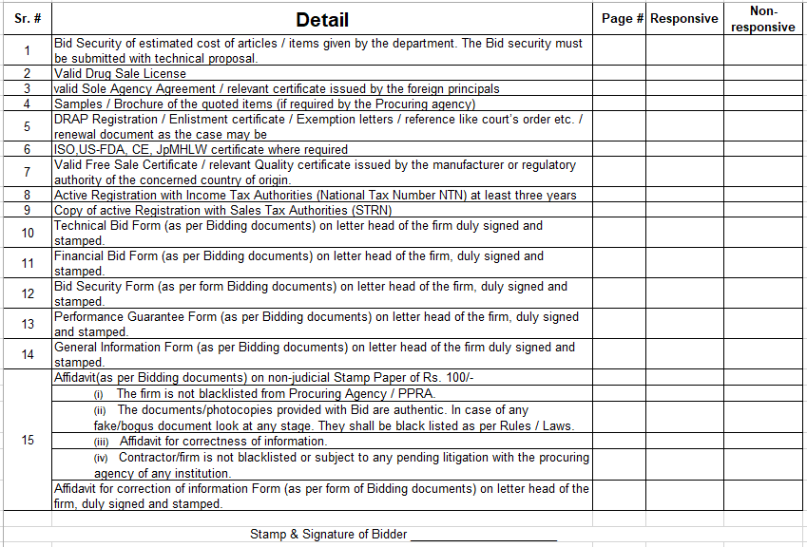

SIGNATURE OF PURCHASE COMMITTEE

PAK RED CRESCENT MEDICAL & DENTAL COLLEGE/ TEACHING HOPSITAL
DINA NATH, 48KM MULTAN ROAD
LAHORE
________________________________________________________________________

Manager Pharmacy Director Purchase
Pak Red Crescent Teaching Hospital , Pak Red Crescent Teaching Hospital
PRCTH PRCTH

Medical Superintendent Principal
Pak Red Crescent Teaching Hospital,
PRCTH Pak Red Crescent Medical & Dental College / Teaching Hospital, PRCM&DC

